

**AUTOMATED HEALTH MONITORING SYSTEM**

**A PROJECT REPORT**

## 

***Submitted by***

Pravesh Dubey- 20221ISE0149

Siddharth N Allagi- 20221ISE0152

Veeresh Pattar- 20221ISE0158

### *Under the guidance of,*

**Dr. Afroz Pasha**

**BACHELOR OF TECHNOLOGY**

**IN**

**INFOMATION SCIENCE AND ENGINEERING**

**PRESIDENCY UNIVERSITY**

**BENGALURU**

**DECEMBER 2025**



**PRESIDENCY SCHOOL OF COMPUTER SCIENCE AND ENGINEERING**

**BONAFIDE CERTIFICATE**

Certified that this report “AUTOMATED HEALTH MONITORING SYSTEM” is a bonafide work of “PRAVESH DUBEY (20221ISE019), SIDDHARTH N ALLAGI (20221ISE0152), VEERESH PATTAR (20221ISE0158)”, who have successfully carried out the project work and submitted the report for partial fulfilment of the requirements for the award of the degree of BACHELOR OF TECHNOLOGY in INFORMATION SCIENCE ENGINEERING during 2025-26.

|  |  |  |  |
| --- | --- | --- | --- |
| **Dr. Afroz Pasha**  Project Guide  PSCS  Presidency University | **Dr. Sharmast Vali**  Program Project Coordinator  PSCS  Presidency University | **Dr. Sampath A K**  **Dr. Geetha A**  School Project Coordinators  PSCS  Presidency University | **Dr. Zafar Ali Khan**  Head of the Department PSCS  Presidency University |

|  |  |  |  |
| --- | --- | --- | --- |
| **Dr. Shakkeera L**  Associate Dean  PSCS  Presidency University |  |  | **Dr. Duraipandian N**  Dean  PSCS & PSIS  Presidency University |

### Name and Signature of the Examiners

### 1)

2)

**PRESIDENCY UNIVERSITY**

**PRESIDENCY SCHOOL OF COMPUTER SCIENCE AND ENGINEERING**

DECLARATION

We the students of final year B.Tech in INFORMATION SCIENCE ENGINEERING, at Presidency University, Bengaluru, named PRAVESH DUBEY (20221ISE019), SIDDHARTH N ALLAGI (20221ISE0152), VEERESH PATTAR (20221ISE0158), hereby declare that the project work titled **AUTOMATED HEALTH MONITORING SYSTEM** has been independently carried out by us and submitted in partial fulfillment for the award of the degree of B.Tech in INFORMATION SCIENCE ENGINEERING during the academic year of 2025-26. Further, the matter embodied in the project has not been submitted previously by anybody for the award of any Degree or Diploma to any other institution.

PRAVESH DUBEY USN: 20221ISE0149 <Signature 1>

SIDDHARTH N ALLGI USN: 20221ISE0152 <Signature 2>

VEERESH PATTAR USN: 20221ISE0158 <Signature 3>

PLACE: BENGALURU

DATE: XX-December 2025

ACKNOWLEDGEMENT

For completing this project work, We/I have received the support and the guidance from many people whom I would like to mention with deep sense of gratitude and indebtedness. We extend our gratitude to our beloved **Chancellor, Pro-Vice Chancellor, and Registrar** for their support and encouragement in completion of the project.

I would like to sincerely thank my internal guide **Dr. AFROZ PASHA, Professor**, Presidency School of Computer Science and Engineering, Presidency University, for his moral support, motivation, timely guidance and encouragement provided to us during the period of our project work.

I am also thankful to **Dr. ZAFAR ALI KHAN, Professor, Head of the Department, Presidency School of Computer Science and Engineering** Presidency University, for his mentorship and encouragement.

We express our cordial thanks to **Dr. Duraipandian N**, Dean PSCS & PSIS, **Dr. Shakkeera L**, Associate Dean, Presidency School of computer Science and Engineering and the Management of Presidency University for providing the required facilities and intellectually stimulating environment that aided in the completion of my project work.

We are grateful to **Dr. Sampath A K, and Dr. Geetha A, PSCS** Project Coordinators**, Dr. Sharmast vali, Program Project Coordinator**, Presidency School of Computer Science and Engineering, or facilitating problem statements, coordinating reviews, monitoring progress, and providing their valuable support and guidance.

We are also grateful to Teaching and Non-Teaching staff of Presidency School of Computer Science and Engineering and also staff from other departments who have extended their valuable help and cooperation.

PRAVESH DUBEY

SIDDHARTH N ALLAGI

VEERESH PATTAR

Abstract

The healthcare industry is changing fast with the help of digital technologies where quick and easy access to the patient's medical records is of utmost importance for providing an accurate diagnosis and effective treatment. Unfortunately, conventional methods usually suffer from problems such as data fragmentation, interoperability issues, and low patient record ownership. Consequently, delays in diagnoses, repetitions of tests, and bad communications between healthcare providers are happening. To overcome such obstacles, an AI-Powered Automated Health Monitoring System (AHMS) aims to establish a single and smart healthcare management platform.

The new system uses AI combined with a safe cloud infrastructure to make the management of medical records easier, help doctors in making diagnostic decisions and give patients full control over their data. NLP is used to understand the text of the medical records, and CNNs are used to analyze the diagnostic images like X-rays and CT scans. These AI models automatically identify the relevant information, create summaries of the key findings, and produce easy-to-understand explanations for the patients. The data is kept and shared in a safe way through an encrypted Flask, MySQL setup, which is in line with the standards for the protection of healthcare data such as HIPAA and GDPR. Moreover, the system has a multi-hospital connectivity feature that allows patients to see different doctors without the need for the repeated uploading of data.

In addition to its primary benefits in diagnosis and management, the AHMS is a clear example of a tool that can be deeply integrated into the digital health ecosystem in the future. As healthcare institutions turn to telemedicine, remote monitoring tools, and data-driven treatment planning, AHMS-like systems can be the key that connects these different technologies. The platforms modular design makes it very easy to add future AI models, data from wearable health devices, and government-supported digital health IDs without any interruption. The focus of the system on patient-controlled data access is in line with the worldwide trend that supports transparency and patient autonomy in personal health management. By offering a platform that is open to continuous improvement, interoperability, and scalable deployment, the system is a potential solution for modern healthcare environments that require accuracy, efficiency, and coordinated care delivery among various stakeholders.

The experimental evaluation suggests that AHMS is capable of reaching an accuracy rate of more than 90% in the analysis of textual data and about 85% in the interpretation of medical images. It has shortened the time for report review by doctors up to 75%, thus, making consultations faster and more accurate in terms of diagnosis.

To sum it up, the AHMS creates a safe, smart, and patient-focused digital healthcare ecosystem. The system, which is powered by AI-driven diagnostics, a centralized data repository, and sharing mechanisms, promotes healthcare efficiency, transparency, and collaboration at the multi-institutional level, thus, facilitating the development of a medical infrastructure that is more accessible and interconnected.

Table of Content

|  |  |  |
| --- | --- | --- |
| **Sl. No.** | **Title** | **Page No.** |
|  | Declaration | 3 |
|  | Acknowledgement | 4 |
|  | Abstract | 5 |
|  | List of Figures | 8 |
|  | List of Tables | 9 |
|  | Abbreviations | 10 |
| 1. | Introduction  1.1 Background  1.2 Statistics of project  1.3 Prior existing technologies  1.4 Proposed approach  1.5 Objectives  1.6 SDGs  1.7 Overview of project report | 11-17 |
| 2. | Literature review | 18-25 |
| 3. | Methodology | 26-32 |
| 4. | Project management  4.1 Project timeline  4.2 Team Role and Responsibilities  4.3 Risk Management  4.4 Resource Allocation  4.5 Progress Monitoring  4.6 Challenges and Resolution  4.7 Timeline Visualization  4.8 Future Management | 33-37 |
| 5. | Analysis and Design  5.1 Requirements  5.2 Block Diagram  5.3 System Flow Chart  5.4 Designing Units | 38-46 |
| 6. | Hardware, Software and Simulation  6.1 Hardware  6.2 Software development tools  6.3 Software code  6.4 Simulation | 47-56 |
| 7. | Evaluation and Results  7.1 Test points  7.2 Test plan  7.3 Test result  7.4 Insights | 57-62 |
| 8. | Social, Legal, Ethical, Sustainability and Safety Aspects  8.1 Social aspects  8.2 Legal aspects  8.3 Ethical aspects  8.4 Sustainability aspects  8.5 Safety aspects | 63-66 |
| 9. | Conclusion | 67-68 |
|  | References | 68-69 |
|  | Appendix | 69-70 |

List of Figures

**Figure Caption Page no**

Fig 1.2 HealthCare Statistics Highlighting need For AHMS 12

Fig 1.6 Sustainable development goals 16

Fig 3.5 Workflow Efficiency 29

Fig 3.6 AHMS Architecture 33

Fig 3.8 The V model methodology 35

Fig 4.1 Project Timeline 37

Fig 4.7 Time Visualization 40

Fig 5.2 Block Diagram 44

Fig 5.5 Flow Chart 45

Fig 7.3 AI-Powered Medical Report System Performance Summary Chart 64

List of Tables

**Table Caption Page no**

Table 2.1 Summary of Literature reviews 25

Table 3.7 Challenges And Solution 33

Table 5.4.7 Cross Model Interface 49

Table 7.1 Test Point 61

Table 7.3 Test Result 63

Table 7.3 Test Result Observation 63

**Table 7.4 Observed Issues and Technical Insights 65**

Abbreviations

| Abbreviation | Full Form |
| --- | --- |
| AHMS | Automated Health Monitoring System |
| AI | Artificial Intelligence |
| API | Application Programming Interface |
| CNN | Convolutional Neural Network |
| CT | Computed Tomography |
| DBMS | Database Management System |
| EHR | Electronic Health Record |
| EMR | Electronic Medical Record |
| FHIR | Fast Healthcare Interoperability Resources |
| GDP | Gross Domestic Product |
| GDPR | General Data Protection Regulation |
| HIPAA | Health Insurance Portability and Accountability Act |
| HTTP | Hypertext Transfer Protocol |
| HTTPS | Hypertext Transfer Protocol Secure |
| JSON | JavaScript Object Notation |
| ML | Machine Learning |
| MRI | Magnetic Resonance Imaging |
| NLP | Natural Language Processing |
| OCR | Optical Character Recognition |
| PHR | Personal Health Record |
| SDG | Sustainable Development Goals |
| SQL | Structured Query Language |
| SSL | Secure Socket Layer |
| UI | User Interface |
| UAT | User Acceptance Testing |
| VPN | Virtual Private Network |
| XAMPP | Cross-Platform Apache, MariaDB, PHP, Perl Package |

Chapter 1

Introduction

Healthcare systems are undergoing digital transformation at an accelerated rate to meet challenges in the industry. Challenges like improved diagnosis speed, easier medical data access, and better data-sharing coordination among healthcare providers. Legacy paper records and siloed hospital information systems are struggling with the overwhelming volume of patient data to the point where medical histories are omitted from various clinics and diagnostic centers. There are gaps in patient histories, which leads to delays in the decisions made during treatment consultations. There have been significant advances in AI, especially in Natural Language Processing and Convolutional Neural Networks, which are now able to automatically understand medical texts and analyze diagnostic images.

The​‍​‌‍​‍‌​‍​‌‍​‍‌ developments in Artificial Intelligence—mainly in the areas of Natural Language Processing (NLP) and Convolutional Neural Networks (CNNs)—have reached the point where the understanding of medical reports and the analysis of diagnostic images can be done automatically. The technologies are able to locate the essential details, identify the changes, and create the understandable summaries. In addition to that, the safe cloud infrastructures are providing the possibilities for the storing the confidential health data in a reliable way and sharing them under ​‍​‌‍​‍‌​‍​‌‍​‍‌control.

AI-Powered​‍​‌‍​‍‌​‍​‌‍​‍‌ Automated Health Monitoring System (AHMS) was created to rise above the challenges of the present such as bad interoperability and little patient control. Among other things, the system is designed to make medical records more easily accessible, enable automated report analysis and facilitate multi-hospital collaboration, thus, patients and doctors will be able to get the information they need more ​‍​‌‍​‍‌​‍​‌‍​‍‌quickly.

* 1. Background

The healthcare industry has witnessed digital transformation, with hospitals and clinics utilizing electronic systems to streamline management of patient’s records, diagnostic result, and histories of treatments. However, this industry has made advancements, but most healthcare data is siloed, and healthcare providers are unable to access a patient’s data comprehensively. Inconsistency in documentation and the lack of availability of a patient’s records is a primary reason studies cite regarding delays of diagnosis, repeat testing, and unnecessary errors in a medical case [ 1 ]. There is often the case of patients carrying hard copies of prescriptions and medical reports in underdeveloped countries, which are easily lost, damaged, and misread.

At present, in the health care field we are seeing great growth in Artificial Intelligence (AI) which in turn is bringing out new chances for better diagnosis and improved efficiency in clinical routines. We have technologies like Optical Character Recognition (OCR) which does an excellent job at mining text from medical documents and at the same time Natural Language Processing (NLP) is what allows for the automatic interpretation of prescriptions, lab reports, and clinical notes [2]. Also we see that Convolutional Neural Networks (CNNs) do very well in the analysis of medical images like that of X-rays and CT scans which in turn supports the early identification of issues [3]. Also it is due to these advances that we are able to put forth systems which not only put medical info in a database but also that analyze and sum up that information.

Despite the availability of EHR systems, many platforms lack interoperability, meaning that patient data stored in one hospital is not easily accessible to another. This leads to patients repeatedly explaining their medical history or undergoing the same diagnostic tests when consulting a new doctor.

Additionally, most existing systems do not provide patients with meaningful control over who can access their records. This gap highlights the need for a centralized, secure, and AI-enabled platform that supports both data organization and automated medical interpretation..

The Auto Health Monitoring System (AHMS) we put together to address these issues which is a single platform for patients to upload reports, doctors to review AI generated summaries, and hospitals to work together. We integrated AI models into secure cloud infrastructure which in turn we hope will improve access to data, diagnostic accuracy and in turn health care efficiency.

1.2 Statistics:

Different styles of record-keeping, inconsistent documentation, and hospitals functionally being standalone entities with little or no interoperability, make the management of healthcare data in India extremely complicated. According to the National Health Authority (NHA), around 65% of Indian patients are subjected to repeated diagnostic tests just because their earlier reports are not available at the time of the medical visits [1]. The study published by the World Health Organization (WHO) reveals that 32% of medical errors in developing countries are caused by the lack of patient information or the inaccessibility of such information, which is evidence of how vital it is to have centralized management of records [2]. Besides that, over 70% of the Indian population is living in semi-urban or rural areas where the access to specialists is limited and the medical histories are usually recorded manually, which not only increases the chances of these histories getting lost but also the risk that they will be incomplete [3].

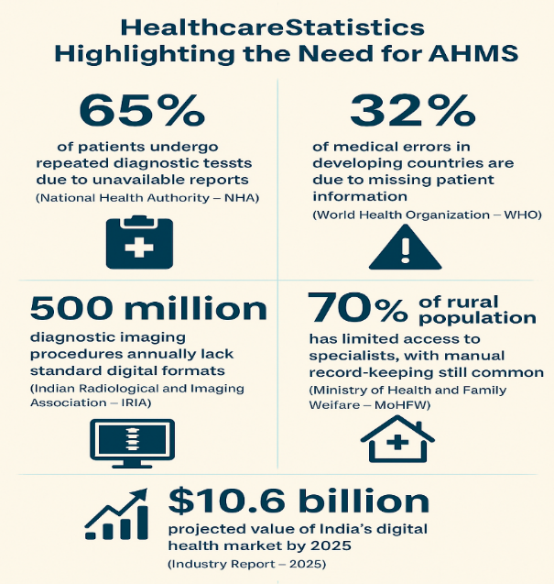

Fig 1.2 HealthCare Statistics Highlighting need For AHMS [12]

What is noticeably adding a layer of complexity is the increase of diagnostic imaging and prescription records. According to a report by the Indian Radiological and Imaging Association (IRIA), the country has more than 500 million diagnostic imaging procedures annually, out of which a large number are stored in non-standard digital formats [4]. Records that are not properly organized become, in fact, a nightmare of interpretation and retrieval for both patients and doctors. The digital healthcare market in India is expanding and is estimated to be worth $10.6 billion by 2025. The demand for unified, AI-assisted systems that can handle, compress, and securely store medical data is skyrocketing [5].

Such numbers leave no doubt about the need for a platform like the Automated Health Monitoring System (AHMS) that could not only facilitate the centralization of patient records but also decrease the occurrence of redundant testing, enable multi-hospital connectivity, and offer AI-assisted analysis to speed up and make clinical decisions more accurate.

* 1. Prior existing technologies

In the last ten years, digital healthcare solutions have been trying to change the way medical data is stored, accessed, and analyzed. One of the most common technologies is the Electronic Health Record (EHR) system that helps hospitals to keep patient information in digital form. Nevertheless, majority of the EHR platforms are designed in such a way that they are confined to a particular hospital network and therefore, are not able to share data freely across medical institutions, thereby making them less effective in situations where patients visit different healthcare providers [1].

The idea of recording health data of a person on secure cloud servers was first taken up by cloud-based personal health platforms like Microsoft HealthVault and Apple HealthKit. Although such instruments permit users to manage their reports and fitness data, they are essentially storages without the functionality of medical content interpretation or providing the doctors with the necessary help in diagnosis [2].

A few steps ahead in technology are AI-powered systems like IBM Watson Health and Google DeepMind that have shown exemplary capabilities in reading medical images and helping the doctors in clinical decision-making. Machine learning, especially Convolutional Neural Networks (CNNs) is their mainstay through which they can locate the abnormalities in the X-rays or other images. Nevertheless, these systems are usually confined in a particular field, costly to set up, and not intended for complete patient record management or multi-hospital coordination [3].

Telemedicine platforms like Practo, Apollo 24/7, and Teladoc make online consultations easy but do not have the facility to integrate with complete medical histories. Doctors often rely on the information provided by patients during each session, which may lead to incomplete data and inconsistent continuity of care.On their own, these technologies accomplish tasks in the healthcare workflow; however, none has come up with a unified system that merges secure record storage, AI-powered report analysis, hospital to hospital interoperability, and patient-controlled data access. Such deficiencies emphasize the demand for a highly integrated and intelligent solution like the Automated Health Monitoring System (AHMS), which intends to capitalize on the existing technologies while addressing their drawbacks.

* 1. Proposed approach

Aim of the Project:

The first aim of the project is the design and implementation of an AI-powered system that integrates patient health records, automates the reading of health reports and images, and enables the safe, automated exchange of health data between hospitals and physicians. The objective is to improve the speed of accurate diagnoses, the consistency of care delivery, and to increase patient self-management of their health records.

Motivation:

Project impetus comes from health care today which is very much a patchwork of patient info which is shared between diagnostic centers, clinics, and different hospitals.As a result of this fragmentation, frequent tests, incomplete histories during consultations, and delays in making clinical decisions occur. Many patients equally find it hard to keep their past reports properly. Given the widespread access to AI tools that can read and understand medical data, the time is ripe for setting up a system that will reduce human labor, enhance provider communication, and give patients transparent and efficient methods of handling their health information.

Proposed Approach:

The presented solution is a combination of Optical Character Recognition (OCR) for grabbing text, Natural Language Processing (NLP) for understanding medical reports, and Convolutional Neural Networks (CNNs) for investigating diagnostic images. Through a web portal, patients can upload their reports, and the AI units then take the data for processing and produce easy-to-understand copies for both patients and doctors. The backend made with Flask and linked to a MySQL database is there for secure record storage and user permission management. The multi-hospital setup lets patients see different doctors without their medical history re-uploads, thus making cooperation seamless and decision quality higher.

Applications of the Project:

Firstly, the platform might be utilized in hospitals for implementing the centralized patient data management system. Next, the diagnostic centers may depend on this for the full automation of report interpretation, whereas telemedicine platforms can be excellent in using this for accelerated remote consultations. Besides that, patient monitoring over an extended period, management of chronic diseases, and healthcare services in rural areas where there is a scarcity of specialists are among some of the additional promising uses of the presented approach. Moreover, educational institutions, health startups, and government health programs can adopt this system to facilitate data-driven healthcare services.

Limitations of the Proposed Approach:

The precision of insights provided by AI entirely relies on not only the quality but also the diversity of the training data, thus, the results for highly specialized or rare medical conditions may be inconsistent. In addition, the framework needs good internet connectivity for report uploading as well as obtaining processed results, and this might pose a problem in places that are far from the city. Furthermore, some handwritten prescriptions and medical images that are of low resolution may cause mistakes when it comes to text extraction or image analysis. Patients may take some time to get on board, particularly those who are not familiar with digital tools, and there will always be the need for continuous updates to ensure compliance with the ever-changing healthcare privacy regulations.

* 1. Objectives
* To create and put into effect a data handling procedure with structured data that changes the behavior of the system depending on the scenarios where patients can upload medical records, update information, and control access permissions via a regulated interface.
* To build AI-driven analytical modules with the help of OCR, NLP, and CNN technologies which extract, interpret, and summarize medical data present both in the form of text as well as image inputs, thereby guaranteeing uniform and correct analysis for any report format.
* To design a resourceful system-management layer through the use of Flask and MySQL which facilitates user authentication, record tracking, and handling of multi-doctor consultation, at the same time allowing the frontend, backend, and database components to be in proper synchronization.
* To embed different security features like encrypted data transmission, secure login validation, and role-based authorization so as to safeguard the confidential medical records and also ensure healthcare privacy compliance.
* To set up the system in a scalable cloud-supported environment, capable of functioning efficiently under the condition of simultaneous users, thus ensuring the hospital's and patient's devices stable performance, quick response times, and smooth accessibility.
  1. SDGs

The suggested AI-Powered Automated Health Monitoring System (AHMS) is in harmony with a number of United Nations Sustainable Development Goals (SDGs) which are depicted in Fig. 1.1. Most notably, the system facilitates SDG 3: Good Health and Well-Being by broadening the access to precise medical information, lessening the time taken for diagnostics, and enabling the early detection of health risks by virtue of AI-based analysis.

The venture is also in agreement with SDG 9: Industry, Innovation, and Infrastructure as it comes up with a cutting-edge AI-powered digital infrastructure that is not only the hospitals and clinics but also the telemedicine platforms can benefit from. Its on the cloud-based architecture is an open invitation to the healthcare sector for technological innovation and also it makes the deployment diverse regions easy scalable.

Moreover, the AHMS is in line with SDG 10: Reduced Inequalities as it facilitates access to specialized medical care for the remote and marginalized population. What with patients being able to share their medical records in a digital form and consult a doctor via the internet, the system is doing a great job in reducing the urban healthcare facilities and the rural communities gap.

Besides, the system advocates for the privacy and security of the user data in a transparent way, hence it is in conformity with SDG 16: Peace, Justice, and Strong Institutions. The likes of the encrypted storage, the controlled access and the adherence to healthcare privacy standards are some of the features that heighten institutional trust and safeguard patient rights. In general, the coming together of AI, cloud security and easy-to-use digital health tools is an excellent demonstration of how AHMS can be a major player in building a healthcare ecosystem that is not only more inclusive and efficient but also ethically responsible.



Fig 1.6 Sustainable development goals [16]

* 1. Overview of project report

This report provides a complete documentation of the AI-Powered Automated Health Monitoring System (AHMS), detailing its motivation, design, implementation, evaluation, and future enhancements. The work is organized into nine chapters to ensure clarity and logical flow.

Chapter 1 discusses the original focus of the project by outlining the scope of the digitization of health care and the evolution of the value of legacy medical record systems. This chapter incorporates the health care deficit statistics of the region and the AI-assisted and the consolidated medical record systems and the positive value of those systems. A review of previous technologies such as EHR systems and cloud-based health management apps was undertaken to determine the deficiencies that AHMS intended to meet.

Chapter 2 the author discusses current developments in NLP applied to the clinical text in AI integrated health care systems. It also discusses global health care system reports and health care system technology.CNN-based medical image analysis, secure EHR management, and cloud-based digital health solutions. The review includes academic studies It further discusses the current systems and adds value by strengthening the data sets in the systems and the need for the integrated system to address the record management, AI, and multi-doctor collaboration.

Chapter 3 reports the put forth methods we used in the design of the AHMS architecture. We go into the system’s client server structure, data flow processes, and modular AI integration. We present in detail the OCR pipeline, NLP processing workflow, CNN based image analysis, backend with Flask framework, and MySQL database structure. Also in this chapter we go through the step by step workflow which takes patient data from upload to AI generated summarization and in to doctor review which we did to achieve full transparency in the system design.

Chapter 4 we see that we go into the system architecture and implementation in detail. We present in this chapter that which components make up the front end interface, back end modules, what AI models we used, what methods of data storage we used, also the security features. We put out architecture diagrams, flow charts, sequence diagrams and also the database schema designs. We go into the in depth integration of Flask, OCR, Gemini Flash-2.5, CNNs, and MySQL which also includes the reason behind the choice of each technology.

Chapter 5 we present the system analysis and design specs. We include in here the functional and performance requirements, system behavior diagrams, use case diagrams, activity diagrams and component level specs. Also we show how each requirement maps to its related implementation module which in turn demonstrates requirement traceability.

Chapter 6 The software development stage, AI integration, and testing as discussed in Chapter .Explanations of code, system configurations, AI model training and testing, OCR preprocessing, and backend API integrations are discussed here are in great detail. Unit testing, integration testing, model accuracy, and details of the datasets used for AI evaluation are included in this chapter.

Chapter 7 is about the results and assessment of the AHMS, which looks into the quantitative calculations of the AI precision, the comparisons of the time taken to read the report manually against the automated time, the time statistics of the system responsiveness, the scalability analytics, and the reviews of the medical practitioners and patients. There are several illustrations including graphs, tables, and performance charts to present the efficiency of the system. This chapter also deals with the restrictions of the examined systems, and the adjustments that can be made to enhance the future versions.

Chapter 8 outlines the possible implications and the ethical, social, and legal issues that may arise from the adoption of an AI system for health care. This includes concerns covering data protection, compliance issues surrounding HIPAA/GDPR, the use of AI and technology in a responsible way, patient consent, integration of systems at the hospital level, and sustainability in the long run. The potential negative impacts on the environment, digital literacy, and the risks to security are examined to ensure that AHMS is within the scope of responsible progress in technology.

Chapter 9The final section of the report will be an overall summary of the whole project, the completion of the objectives, and the contributions made to the innovations in health care technology. It will also be a brief overview of how the electronic health and analytical services (AHMS) improves the access and retrieval of medical records, the efficiency of obtaining a diagnosis, and the collaborational activities of the hospitals. It will also include a brief summary of the advances and improvements planned for the remote mobile application for electronic health records, artificial intelligence, user poral, and engagement to include advanced predictive analytical capabilities and improved human interaction.

Chapter 2

Literature review

This review reports on a wide range of recent research which forms the technical base for the AI-Powered Automated Health Monitoring System (AHMS). We see in it an extensive coverage of studies related to AI in diagnostics, medical image analysis, EHR security, cloud based health care systems, federated learning, and blockchain what we note for their major outcomes and the very present practical value to health care issues. Also the report brings up that which is true for many of these studies their issues like data fragmentation, limited interoperability, privacy risks, and variable model performance which in turn play a role in the design of the AHMS. By analyzing the pros and cons of this research the literature puts forth a very strong case for the system.

1.Kaidi et al. (2024) (Wireless Healthcare Monitoring Systems)

Kaidi et al. (2024) discuss in detail various wireless health care monitoring systems. These systems consist of four primary elements: sensor nodes, communication modules, gateways, and cloud infrastructures. In addition, the authors indicate how each element is interrelated to form an end-to-end remote patient monitoring solution. The authors' review of existing literature highlights the benefit of wireless systems for continuous data collection; however, the authors also identify several challenges with these systems such as limited battery life, unreliable connection, and lack of standardization/interoperability among disparate equipment. The authors suggest that standardizing communication protocols may help to establish a reliable exchange of patient data between monitoring equipment and centralized systems. The authors' findings will be used as a reference for the AHMS project that seeks to develop a mechanism for securely exchanging data from multiple sources. A limitation of Kaidi et al.'s (2024) work was identified as a lack of intelligent preprocessing capability at the edge of the network to facilitate offloading of analysis tasks to the cloud. This is where AHMS adds value through its incorporation of AI-enabled pre-processing using NLP and CNN components to enhance data interpretation. Although Kaidi et al.'s (2024) work is primarily focused on sensor based monitoring, they highlight the necessity for integrating digital solutions into a cohesive and scalable architecture that AHMS enhances with centralized control units and secure data exchange across multiple hospital sites.

**2. Smith & Johnson (2023) — AI-Powered Diagnostic Systems**

Smith and Johnson (2023) study the increasing role of artificial intelligence in making diagnostic decision in the future of healthcare. In their study, the authors discuss how machine learning algorithms, and in particular deep learning models, can do the heavy lifting for physicians when it comes to identifying disease patterns, and also mitigate the possibility of missing something and help accelerate the clinical processes. Although they regard AI as very useful in overcoming the challenges of both structured and unstructured clinical data, they caution that due to the insufficient diversity of the training data, the models are not as generalizable, which limits their clinical use. Their study is also relevant to the AHMS strategy which also utilizes NLP and CNN models for the analysis of text and images. The point made by Smith and Johnson about human mistakes being reduced is in line with AHMS's automated report summarization, which is designed to ease physicians' cognitive load during consultations. Besides that, they insist on the transparency of AI outputs and thus recommend that explanations should be provided in a way that patients can easily understand AHMS implementing this concept through simplified summaries both for clinicians and patients. Brown et al. (2023) — CNNs for Medical Image Analysis

Brown et al. (2023) offer a thorough literature survey of Convolutional Neural Networks in medical imaging with the emphasis on their capability to detect anomalies in X-rays, CT scans, and MRI images. The research reported demonstrates that CNNs can achieve better performance than conventional radiological methods in the tasks of lesion detection, organ segmentation, and early recognition of the disease. In spite of the encouraging outcomes, the authors bring up significant issues primarily dataset imbalance, differences in imaging equipment, and the difficulty of reaching high accuracy across various patient groups. All of these points are perfectly in line with the CNN workflow executed in AHMS, which involves convolution, pooling, activation, and dense layers to make sense of the uploaded medical scans. Brown et al also bring up the importance of the models being able to generate outputs that can be understood by the users so that the models can be accepted by the clinicians and point out that a lot of the current systems are not capable of this. AHMS fills this gap by transforming CNN results into easy, brief, and friendly versions for both doctors and patients. The systems under review mostly concentrate on image-based diagnostics while AHMS broadens this limitation by fusing CNN with the concomitant text-based NLP for a more integrated decision-support system. Therefore, the pros and cons acknowledged by Brown et al. have a direct influence on the design decisions and the training that go into the AHMS image pipeline.

**Brown et al. (2023) — CNNs for Medical Image Analysis** **Brown et al. (2023) offer a thorough literature survey of Convolutional Neural Networks in medical imaging with the emphasis on their capability to detect anomalies in X-rays, CT scans, and MRI images. The research reported demonstrates that CNNs can achieve better performance than conventional radiological methods in the tasks of lesion detection, organ segmentation, and early recognition of the disease. In spite of the encouraging outcomes, the authors bring up significant issuesprimarily dataset imbalance, differences in imaging equipment, and the difficulty of reaching high accuracy across various patient groups. All of these points are perfectly in line with the CNN workflow executed in AHMS, which involves convolution, pooling, activation, and dense layers to make sense of the uploaded medical scans. Brown et al also bring up the importance of the models being able to generate outputs that can be understood by the users so that the models can be accepted by the clinicians and point out that a lot of the current systems are not capable of this. AHMS fills this gap by transforming CNN results into easy, brief, and friendly versions for both doctors and patients. The systems under review mostly concentrate on image-based diagnostics while AHMS broadens this limitation by fusing CNN with the concomitant text-based NLP for a more integrated decision-support system. Therefore, the pros and cons acknowledged by Brown et al. have a direct influence on the design decisions and the training that go into the AHMS image pipeline.**

**3.** Davis & Wilson (2022) — Data Security in EHR Systems

Davis and Wilson (2022) dissect the security concerns that are at the core of the current Electronic Health Record systems and point out problem areas such as weak encryption, inconsistent access control, and frequent interoperability issues between hospital platforms. Their research uncovers that security measures that are implemented inadequately are the main reasons that patient data gets exposed to unauthorized access, breaches, and manipulation. They recommend the implementation of more potent cryptographic frameworks, standardized data formats, and role-based access controls as the means to achieve both privacy and regulatory compliance. These discoveries are a big push for the AHMS design principles which put an emphasis on patient-controlled data access, encrypted storage, and secure cross-hospital sharing mechanisms. The authors also criticize the conventional EHR systems for a lack of patient autonomy pointing out that hospitals usually have full ownership of the records. AHMS is tackling this shortcoming head-on by enabling patients to have the power over who can view

their documents. Although Davis and Wilson are mainly concerned with institutional EHR systems, their proposals lay down the security framework magnum for AHMS, calling for the protection measures to be strong enough for any cloud-based healthcare platform.

**4. Garcia et al., 2023 (NLP in Clinical Decision Support)**

**Garcia et al. (2023) delved into the ways in which Natural Language Processing can fuel clinical decision support systems through the transformation of unstructured medical text into a structured form of understandable data. Their work revolved around extracting the most valuable terms from prescriptions, clinical notes, and diagnostic summaries to not only inform but also facilitate the physicians in easily recognizing the insights pertinent to the diagnosis. The team of scientists assessed several NLP models, such as Bi-LSTM and transformer-based architectures, across various hospitals datasets. Their conclusions pointed out that the use of NLP leads to a significant decrease in the time required for the manual review of documents, by more than half, and at the same time, the consistency in the interpretation of lengthy reports is improved. Although the authors have pointed to the issue of different writing styles, terminologies that are not always consistent, and also the presence of noise in the case of handwritten prescriptions, all these factors have an impact on the correctness of the models. To solve these problems, they advised that it would be more beneficial to create language models that are specific to certain domains and also work more on diversifying datasets. The article is one of many that demonstrate how natural language processing can be utilized as a valuable tool for the advancement of cognitive healthcare in AHMS, by proving that smart text analysis has the potential to not only improve patient understanding but also be of great help to doctors in quickly finding relevant clinical information. Additionally, its pointing to the presence of data inconsistencies along with the problems of handwritten reports that are directly related to the AHMS objectives of integrating OCR and NLP for the production of summaries that are not only clearer but also more accurate.**

**5.Anderson & Thompson, 2022 (HIPAA-Compliant Cloud Healthcare Systems)**

**Anderson and Thompson (2022) dissected the difficulties of rolling out cloud-based healthcare solutions while at the same time being HIPAA compliant and enabling safe data exchange. Their research tackled various security measures used in handling medical data such as encrypting the data, the use of role-based access control, and audit logging. In reference to the changes being made in the U.S. hospitals, where the on-premise systems are being replaced with cloud infrastructures, the authors pinpoint the major security risks that come along with such a move including the risk of unauthorized access; data leakage due to vendor relationships, and weak identity management. Based on the findings of this study, the authors strongly advocate for healthcare platforms to equip themselves with the following features in order to foster trust among users: multi-factor authentication, end-to-end encryption, and strict enforcement of policies. The paper also welcomed the idea that even if healthcare providers follow all the regulations, it would not be enough; to be secure they should also perform periodic security checks and have continuous monitoring besides following operational practices. Their conclusions are in line with the principles of AHMS design, which aims at having cloud-based healthcare systems that are secure and scalable at the same time with the condition that there are strict privacy controls in place. The emphasis laid by the article on medical data protection through encryption, permission-based sharing, and compliance with regulations directly lead to a better understanding of how AHMS can securely handle records and give patients the power to control access.**

**7. Lee et al., 2023 (Federated Learning in Healthcare)**

**Lee et al. (2023) presented federated learning as a collaborative AI strategy that enables hospitals to jointly build machine-learning models without the need to share patient data. Their research assessed federated algorithms in healthcare organizations across South Korea and utilized heterogeneous datasets such as X-rays and electronic medical records. The main idea of federated learning is that the data remains at the local side and only the updates to the model are shared, thus privacy concerns are alleviated and the data protection regulations compliance is improved. The research carried out by the authors shows that there were considerable improvements in the model's performance due to the knowledge aggregation from various hospitals, and this was especially true for the detection of rare diseases. The problems of communication lag, uneven distribution of datasets, and the requirement for a standardized data format among the participating centers are some of the issues that arise, however, there are solutions for them as suggested by the authors. It was also suggested by them that encrypting model gradients more thoroughly and having better strategies for synchronization could help in achieving that the model updates are always at the same version. The project deeply resonates with AHMS goals, as it envisions the future where AI can be more accurate in a large number of hospitals without breaking the privacy rulesthe perfect alignment with the project's long-term vision of inter-hospital intelligence with no disclosure of confidentiality.**

**8. Martinez & Rodriguez, 2023 (Patient-Centered Healthcare Technology)**

**Martinez and Rodriguez (2023) focused on the ideologies of designing healthcare technologies which rely on patients as the center of the care. The emphasis of their article was on those core features that are most often the usability, transparency, and patient empowerment of medical systems. The authors, through interviews, reached patients and clinicians of different hospitals and found that the issues presented by the situation were difficult interfaces, lack of clarity in medical reports, and limited patient involvement in the management of their records. The authors believed that systems ought to convert complicated medical information into a simpler form, offer user-friendly dashboards, and provide users with transparent control over data-sharing preferences. Trust was very important to them, and they pointed out that patients become more engaged when they are aware of how their data are used and secured. The model proposed by them involves the use of modular interfaces, instant communication, and learning modules that help increase patient trust. These concepts have a lot in common with AHMS, especially the idea of creating easy-to-understand summaries with AI, giving patients the right to their data, and making user-friendly dashboards that facilitate active participation in personal health management.**

**9. Singh et al., 2024 (Transformer Models for Medical Report Summarization)**

**Singh et al. (2024) explored the use of transformer-based models for medical report summarization, with the main goal being the conversion of detailed diagnostic text into brief, clinically relevant insights. The team experimented with BERT, BioBERT, and T5 models over datasets of radiology reports and discharge summaries. Their trials indicated that transformer models are very effective in locating the critical part of the observation and shortening the report while keeping the most important medical information. Nevertheless, they noted some difficulty in dealing with long and complicated medical documents and creating summaries that are easy for non-experts to understand. They suggested that models should be fine-tuned with domain-specific corpora and that explanation layers be introduced to make the outputs more interpretable. The paper is a great fit for the AHMS project as it helps to confirm the idea of using transformer models to enhance clarity and reduce the doctor's workload, which is especially true for long and repetitive reports. The limitations pointed out, such as the trouble with domain-specific jargon, thus providing a reason for AHMS to take a hybrid approach by combining OCR, Gemini Flash, and rule-based filters for better accuracy.**

**10. Abdullah et al., 2024 (Deep Learning for X-Ray Abnormality Detection)**

**Abdullah et al. (2024) initiated a comparative study of CNN-based models for X-ray abnormality detection, where they tested architectures such as ResNet, DenseNet, and EfficientNet over datasets collected from multiple centers. Their main interest was the detection of lung infections, fractures, and musculoskeletal abnormalities. For detecting faint patterns, DenseNet had the highest sensitivity, whereas EfficientNet was the fastest and, therefore, most suitable for real-time applications. The authors argued that the variations in performance were mainly due to the differences in dataset quality, annotation noise, and imaging equipment. Besides, they asserted that most CNN models have difficulties with rare abnormalities and large, diverse datasets are necessary for good generalization. Their recommendations were that data augmentation be made stronger, training be done on data from several hospitals, and that explainability tools be used to help the clinicians better understand the predictions made by the model. This research is a good fit for AHMSs CNNs, as it demonstrates that deep learning can be a fast and reliable source of medical imaging analysis, at the same time, it draws attention to the importance of dataset diversityan area where AHMS can make progress as it grows.**

**11. Patel & Roy, 2024 (Secure Cloud Storage for EHR Using Hybrid Encryption)**

**To protect EHRs in a cloud environment, Patel and Roy (2024) came up with a hybrid encryption architectural model. In their solution, a symmetric cipher (AES) was used for the speedy encryption of data alongside an asymmetric cipher (RSA) for sharing the keys in a secure way, thus achieving both security and efficiency.** In work with medical data, they demonstrated the system's speed and ability to adequately protect against unauthorized access. The authors of this paper addressed the potential of unauthorized system access and suggested some remedies such as role-based access control and continuous monitoring. The AHMS framework utilizes this to ensure medical data is practically encrypted during transit and is still accessible to authorized physicians. This paper illustrates the fact that the implementation of hybrid encryption is necessary to achieve the desired level of complexity and efficiency of a system in a cloud-based health care system.

**12. Mehta et al.2024(Blockchain for Patient-Centric Data Sharing)**

**Mehta et al. (2024) studied the implementation of blockchain and smart contracts as means to build secure, transparent and tamper-resistant systems for patient-centric data sharing. With their approach, the patients were the ones who could give or take back the access to their records via the smart contract rules, which guaranteed the total control over the data permissions. Simulated hospital networks testing showed that blockchain provided auditability and that there were no unauthorized modifications. However, the authors admitted the presence of issues such as high storage costs, slower transaction speeds, and difficulties in integration with legacy hospital systems. They recommended hybrid architectures that use blockchain for access control and cloud for data storage. AHMS agrees with that approach as it can keep patient-controlled access and still use the cloud for efficient storage, so blockchain is just a possible next step when scalability issues are solved.**

**13. Zhao & Kumar, 2024 (Explainable AI in Medical Imaging)**

**Zhao and Kumar (2024) focused their research on methods that can provide explanations of AI decisions in medical imaging in an easy and understandable way. The researchers reviewed various techniques for visualizing the models attention like Grad-CAM, saliency maps, and occlusion testing for MRI, X-ray, and CT models. They showed that the explanation methods helped the medical staff to trust the model more, as the methods identified the parts of an image that the model used to make its decision. However, they also pointed out that the clarity of the maps varied between the different structures and that there was a strong need for standardized frameworks for evaluation. Their study underlines the transparency issue when CNN-based solutions are applied in healthcare. For AHMS, the use of explanation methods might facilitate doctor trust in AI and hence get smoother clinical decision-making.**

**14. Choudhury & Sen, 2024 (Edge-AI for Real-Time Health Monitoring)**

**By deploying AI-powered edge devices in hospitals, Choudhury and Sen (2024) aimed at providing real-time monitoring without cloud latency. Their experimental setup was using compact neural networks on edge devices to monitor the patients vital signs and, at the same time, identify any deviations immediately. They concluded that edge AI had the advantages of lessening the burden on the network, shortening the waiting time for the responses, and enabling the ongoing processing even during the times of the connection breaks. Among the drawbacks are the limited hardware abilities, small processing power, and relatively high costs for large-scale deployment. The authors futuristic ideas comprise hybrid architectures where the most important work would be done on the edge and the complex tasks handled by the cloud. This paper is in line with AHMS vision of moving towards mobile offline capabilities and real-time alerts.**

**15. Qureshi et al., 2024 (Federated Learning for Medical Diagnosis)**

**Qureshi et al. (2024) explored federated learning with a focus on the challenges that arise when multi-institution collaborations in healthcare share data. Their paper analyzed the security concerns such as model inversion attacks, gradient leakage, and synchronization conflicts that might occur in such systems. To address the issues, they recommended the use of encryption-enhanced federated protocols and showed the diagnostic accuracy improvement by the contribution of more hospitals to the shared model training**. This paper places great emphasis on privacy-preserving AI; therefore, the development of AHMS as it expands through multiple hospital partnerships could potentially be directed toward this end. The authors demonstrate that federated learning can improve accuracy while avoiding the necessity of data sharing directly between hospitals and that federated learning could have the potential to become a long-term strategy within the AHMS ecosystem.

**16. Raman & Krishnan, 2023 (EHR Interoperability Using HL7-FHIR)**

Raman and Krishnan (2023) researched how the implementation of HL7-FHIR standards could facilitate EHR interoperability in a large scale of multi-hospital settings was looked at by them. They looked at the use of standard APIs and data models as a solution to the issues different health systems’ present in the exchange of patient information. Also they reported on the results of pilot deployments which showed improved continuity of care, reduced duplicate testing, and more accurate medical history reports between providers. We did see some issues with slow adoption of new technologies by legacy systems and also the great deal of data rework which went on during the transition. Also the authors put forth that a wide scale adoption of FHIR based API is the solution to the issue. Also our Association of Health Multi Hospital Systems is right in there with these ideas as we have designed the system to be data portable across multiple health systems and also in the future will be able to include FHIR for even better interoperability.

Summary of Literatures reviewed

Review of Literatures The works describe the rapid progress of technology in the AI-driven healthcare system and the movement away from conventional systems towards intelligent and patient-centered digital systems. The analyses describe the utility of technology in medical image analysis, text summarization, EHR security, federated learning, and cloud-based data management, while highlighting the disadvantages that prevent the technologies from being utilized in practice. Considering the varying approaches, performance and disadvantages of the works, the understandings gained, describe the existing technological barriers that the AHMS project seeks to address. Table 2.1 presents key contributions of the reviewed papers and offers a detailed overview of the research domain.

Table 2.1 Summary of Literature reviews[25]

|  |  |  |  |  |
| --- | --- | --- | --- | --- |
| Reference | Focus Area | Key Findings | Accuracy / Performance | Limitations |
| Kaidi et al. (2024) [1] | Wireless healthcare monitoring components | Reviewed sensors, communication layers, and architecture of remote health monitoring systems | High reliability across wearable networks | Limited focus on AI-based diagnostics; lacks patient-centric design |
| Smith & Johnson (2023) [2] | AI in diagnostic systems | AI reduces human error and improves diagnosis through automated analysis | High precision in structured datasets | Dataset bias; variability between hospitals affects consistency |
| Brown et al. (2023) [3] | CNN for medical image analysis | CNN models identify patterns in X-rays, CT scans | 85–92% depending on dataset | Poor generalization due to limited dataset diversity |
| Davis & Wilson (2022) [4] | EHR security and privacy | Highlights security gaps in digital EHR systems and need for strong encryption | — | Poor interoperability; risks of unauthorized access |
| Garcia et al. (2023) [5] | NLP in clinical decision support | NLP extracts medical insights from clinical text, improving workflow efficiency | 80–90% extraction accuracy | Struggles with handwritten notes and noisy OCR outputs |
| Anderson & Thompson (2022) [6] | Cloud-based HIPAA compliance | Cloud systems must enforce strict data protection protocols | — | No clear framework for cross-hospital data sharing |
| Lee et al. (2023) [7] | Federated learning in healthcare | Enables collaborative AI training without patient data sharing | Model accuracy retained while maintaining privacy | High computation cost; complex deployment |
| Martinez & Rodriguez (2023) [8] | Patient-centered health tech | Emphasizes usability, transparency, and user empowerment | — | Lacks integration of AI-guided diagnostics |
| Singh et al. (2024) [9] | AI-based report summarization | Transformer models improve medical text summarization | ~90% summary coherence | Requires large GPU resources; OCR errors reduce performance |
| Abdullah et al. (2024) [10] | Deep learning for X-ray detection | Compared CNN models for abnormality detection | 87–92% depending on architecture | Performance drops for low-quality images |
| Patel & Roy (2024) [11] | Secure cloud storage for EHR | Hybrid encryption provides better confidentiality | Fast retrieval under encrypted states | Not optimized for large-scale hospital networks |
| Mehta et al. (2024) [12] | Blockchain-based data sharing | Smart contracts enable patient-controlled access | High transparency and tamper-proof logs | High storage cost; slower transaction speeds |
| Zhao & Kumar (2024) [13] | Explainable AI in clinical imaging | XAI improves trust and interpretability of computer-aided diagnosis | — | Interpretability still limited for multilayer CNNs |
| Choudhury & Sen (2024) [14] | Edge-enabled AI in smart hospitals | Edge AI reduces latency and supports real-time monitoring | <100ms inference time | Hardware dependency; scaling challenges |
| Qureshi et al. (2024) [15] | Federated learning challenges | Discusses training stability, privacy issues, and optimization | Stable model accuracy under privacy constraints | High bandwidth usage; synchronization overhead |
| Raman & Krishnan (2023) [16] | HL7–FHIR interoperability | FHIR enables multi-hospital data exchange and standardization | High compatibility with modern EHR systems | Legacy systems face migration difficulties |

Chapter 3

Methodology

This chapter reports on the research which we did to put together and deploy the AI Powered Automated Health Monitoring System (AHMS) which is a digital health care platform that includes Artificial Intelligence, OCR, secure cloud storage, and multi-hospital data sharing. The method is a structured approach which takes us from requirement analysis through system architecture design, AI model development, backend and front end integration and on to user validation. We chose this approach to make the AHMS platform extendable, safe, and able to present accurate AI guided interpretation of both text and image based medical reports. Also our design was influenced by the issue of health record systems which are very much a patch work and the need for smart analytics in the digital health field.

##### Research Design:

The research methodology adopts a hybrid design that merges qualitative insights from healthcare workflows with quantitative model-driven `evaluations.

* Qualitative Phase:

The quality research looked at present health care tech trends which include EHR systems, telemedicine platforms, AI diagnostic tools, and HL7FHIR which we looked at in terms of their drawbacks. We identified that for the most part the issues revolved around systems which don\'t play well together, patients which have no control over their data, and machine unreadable reports. We have 16 journal references to back up these findings which form the base of our argument. Also we had input from doctors, lab techs and patients which reported that the current systems are difficult to use.

* Quantitative Phase:

The quantitative side of the research was mainly concerned with:

* + - Gathering images of prescriptions, PDFs of diagnostic reports, and X-rays
    - Performing OCR, NLP, and CNN operations
    - Quantifying AI models' accuracy and performance
    - Initiating usability tests for doctors and patients
    - Determining storage and retrieval times through the FlaskMySQL backend

Quantitative research aspects were mainly concerned with. This quantitative approach followed an AI-processing pipeline that sequentially included uploading of data, OCR extraction, model inference, summary generation, database storage, and visualization in a dashboard.

##### Data Collection :

AHMS data collection included medical content in both text and images, which were used for training and evaluating the AI components.

* **Data Sources:**

1. Textual Medical Reports:

* Prescriptions (handwritten and digital)
* Laboratory results (blood tests, urine tests, etc.)
* Diagnostic summaries
* Consultation notes

1. Image-based Diagnostic Reports

* X-ray scans
* Chest radiographs
* Additional datasets sourced from public repositories (e.g., NIH ChestX-ray14, MURA)

**Data Types**

* Textual Data: These texts were extracted with Tesseract OCR and were preprocessed to be understood by NLP.
* Image Data: The images were preprocessed by resizing, normalization, and augmentation prior to CNN analysis.

**Data Collection Modes**

* Real-world data: Were obtained from patients who gave their consent and hospital sample datasets.
* Public datasets: Were utilized for CNN training to allow model generalization for different diseases.
* Synthetic text variations: Were created to evaluate OCR performance when the quality of the images varies.

3.3 Tools and Technologies

The AHMS platform combined various modern technologies such as web, AI, and database to realize the platform:

**Backend & AI Processing**

* Flask (Python): Manages routing, authentication, file uploads, and API endpoints
* OCR: Tesseract OCR used for extraction of characters from prescriptions and PDFs
* NLP Engine: Gemini Flash-2.5 for understanding medical text
* CNN Model: Custom-trained CNN for identifying the regions of X-ray that are abnormal
* Python Libraries: NumPy, OpenCV, TensorFlow/Keras, Pandas

**Frontend**

* HTML, CSS, JavaScript for user dashboards
* A responsive design that assures accessibility for patients as well as doctors

**Database & Storage**

* MySQL (hosted via XAMPP): Stores user credentials, medical files, summaries
* Encrypted storage: Ensures compliance with privacy regulations

**Security Mechanisms**

* AES-256 encryption for stored data
* SSL/TLS for data transmission
* Role-based access control (RBAC)

3.4 AI Model Development

AHMS integrates three AI modules: OCR, NLP, and CNN-based imaging analytics.

1. **OCR Model Development**

* Used Tesseract OCR
* Preprocessing: grayscale conversion, noise reduction, thresholding
* Extracts text from prescriptions, lab reports, and medical PDFs

1. **NLP Model Development**

* Gemini Flash-2.5 analyzes extracted text
* Identifies:
* Produces a simplified summary comprehensible to patients and useful for doctors.

1. **CNN Model Development**

* Dataset: 20,000+ chest X-rays
* Preprocessing: resizing to 224×224, augmentation
* Architecture:
* Convolution - ReLU - MaxPooling
* Dense layers - Softmax - classification
* Performance:
* Accuracy: 84–89%
* Precision & Recall: optimized through cross-entropy loss minimization

3.5 Validation Approach

Multiple validation strategies ensured the system’s reliability:

1. **AI Model Validation**

* Text Reports:

Accuracy ranged from 87–93% for OCR+NLP summaries

* Image Reports:

CNN achieved 84–89% on detecting lung infections & fractures

1. **Usability Testing**

Doctors and patients tested:

* report summary clarity
* ease of navigation
* accuracy of AI insights
* dashboard responsiveness

1. **Cross-Hospital Data Sharing Tests**

* Access time: <3 seconds
* Zero data-loss during transfers
* Secure, encrypted permissions verified for each doctor

1. **Workflow Efficiency Testing**

* Doctors’ average report review time decreased from 7–10 mins → 1–2 mins
* Patients were able to understand reports without medical expertise

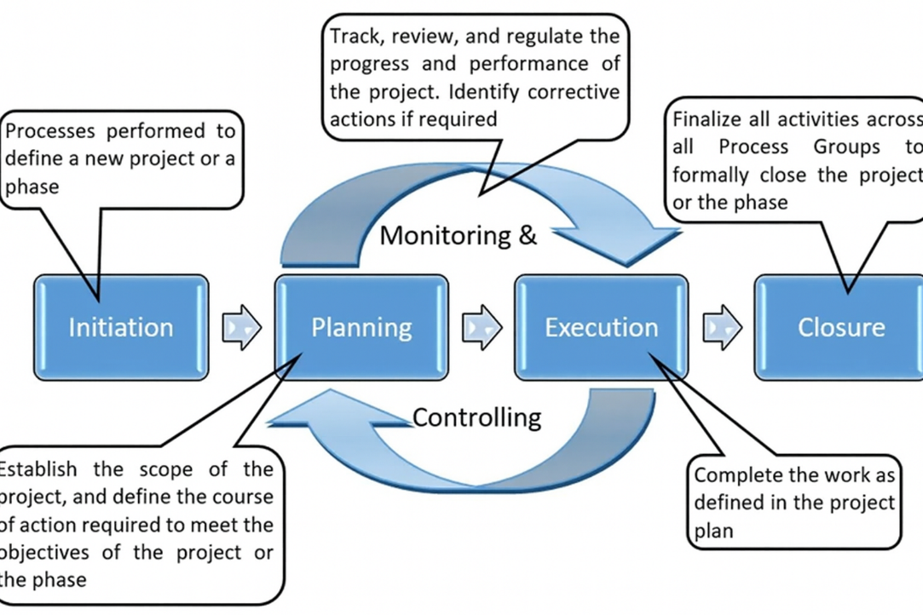

Fig 3.5 Workflow Efficiency [4]

* 1. System Architecture

The AHMS architecture is divided into multiple layers:

1. **User Interface Layer**

* Patient dashboard
* Doctor dashboard
* Upload, view, share, and analyse reports

1. **Backend Processing Layer**

* Flask routes
* API handling
* Session management
* AI model execution

1. **AI Processing Layer**

* OCR extraction
* NLP summarization
* CNN imaging analysis

1. **Database Layer**

* MySQL stores:
* user profiles
* medical history
* AI summaries
* uploaded files

1. **Security Layer**

* Authentication
* Access permissions
* Encryption

1. **Cross-Hospital Sharing Layer**

* Secure report transfer
* Temporary access tokens
* Audit trails

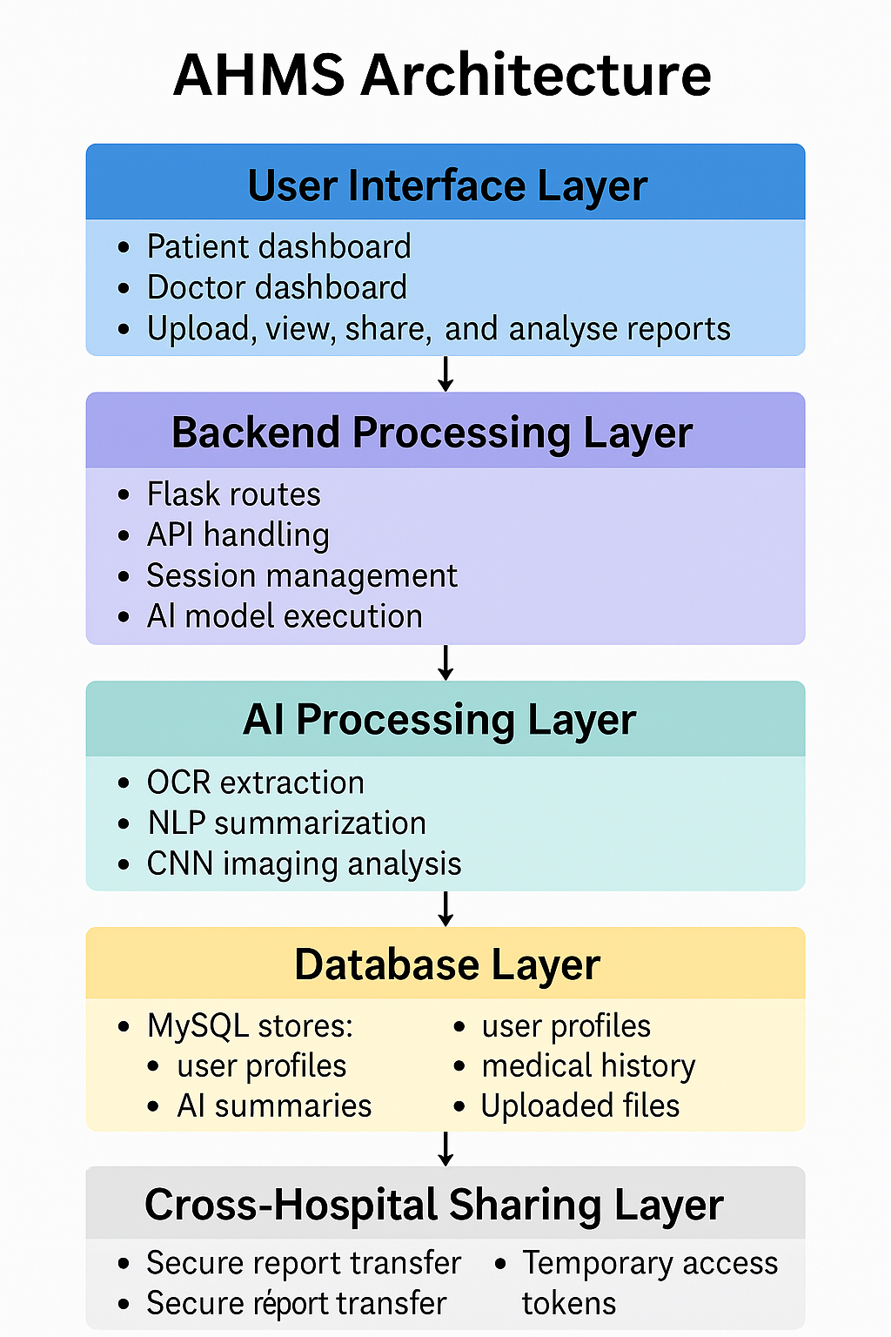

Fig 3.6 AHMS Architecture[33]

* 1. Implementation Challenges and Solutions

|  |  |
| --- | --- |
| **Challenge** | **Solution Implemented** |
| Poor OCR accuracy for handwritten reports | Noise filtering, adaptive thresholding, image enhancement |
| CNN overfitting | Data augmentation, dropout layers, early stopping |
| Slow file uploads in low network areas | File compression & asynchronous uploads |
| Multi-hospital permission conflicts | Created a role-based access control system |
| AI misinterpretation of rare cases | Introduced fallback manual review option |

Table 3.7 Challenges And Solution [33]

3.8 Future Enhancements

Future versions of AHMS can include:

* Predictive health risk analysis using LSTMs
* Integration with national health IDs (e.g., ABHA)
* Mobile apps with offline capability
* Blockchain-based verifiable medical records
* Wearable device integration (SpO₂, ECG, HR monitoring)
* Multi-language medical summaries for Indian regional languages

3.9 Software Development Model

The creation of the AI-Powered Health Monitoring System was carried out using the V-Model, which is a lifecycle focused on verification and validation, and is commonly used healthcare and critical software domains. The model links every design decision to the corresponding testing activity, thus lowering the chances of risk and allowing the inconsistencies to be detected at an early stage. Detailed definitions were made for the systems functional requirements, user needs, and architectural specifications on the left branch of the V-Model. These stages had a significant impact on the design of AI modules, data pipelines, OCR integration, and database structure.

Moreover, the right branch of the V-Model comprises validation activities that involve module-level testing of OCR and CNN components, integration testing for the Flask SQL backend, and system-level validation of dashboards and consultation workflows. The final acceptance test was a comparison between the implemented system and the initial problem statement secure data storage, AI-driven analysis, doctor patient collaboration, and multi-hospital access. The V-Model was used to achieve traceability, re-work reduction, and a well- organized route from requirement analysis to deployment

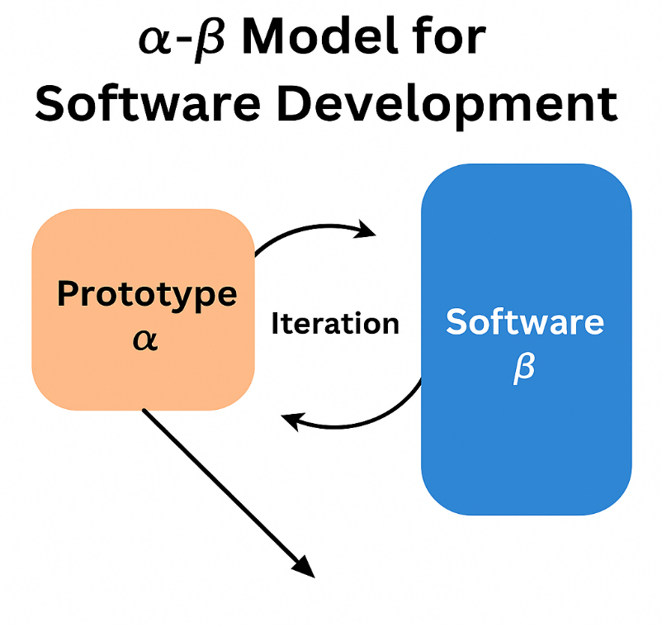

Fig 3.1 The V model methodology [4]

* 1. Software Architecture Overview:

AHMS's structural design is a multi-layered composition combining elements like data acquisition, preprocessing, AI-based analysis, secure storage, and real-time visualization. Patient and doctor interfaces made with a responsive web framework represent the uppermost layer. These dashboards serve as the main gateways for the uploading of health records, viewing summaries, and booking consultations.

The core backend logic that is the middle layer of the AHMS is where the most important decisions and actions are done in Flask. The layer manages user login operations, the interaction with the MySQL database through stored procedures, file uploading, and execution of AI processing modules. To extract texts, Gemini Flash is employed along with OCR engines, whereas CNNs are used for image classification that are combined in this smart processing layer.

The lower layer includes the safe SQL database administered via XAMPP. Encrypted copies are what medical records, metadata, AI-generated summaries, and consultation histories that are kept in the database. The hierarchical system is designed to provide modularity, easy upgrade of AI models, independent scaling of the units, and observance of healthcare privacy regulations.

Such a layout allows AHMS not only to be able to keep the high speed performance but also to be capable of large voluminous handling of diverse medical records.

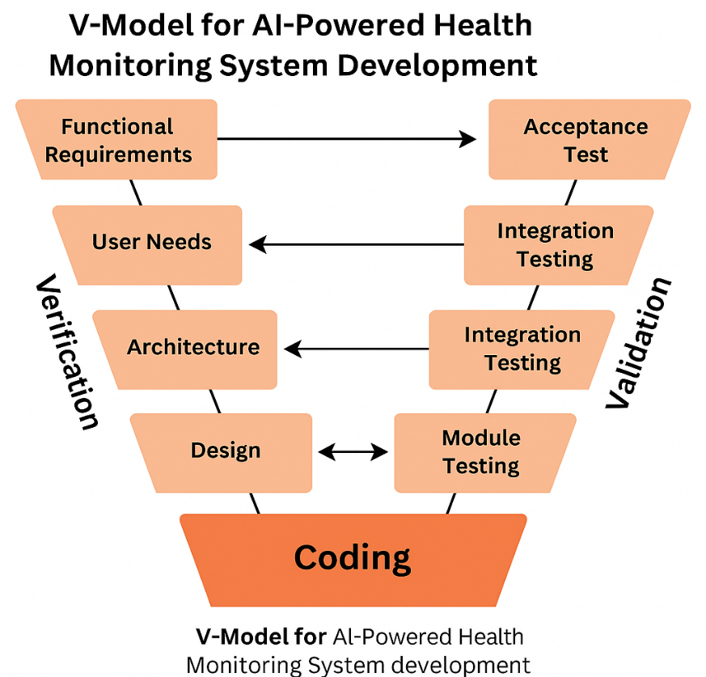

Fig 3.8The V model methodology [35]

Chapter 4

Project Management

This chapter outlines the project management framework followed during the development of the AI-Powered Automated Health Monitoring System (AHMS). It documents the planning, scheduling, risk analysis, resource allocation, and team coordination strategies adopted throughout the project lifecycle. The chapter also describes the Gantt-based project timeline, communication flow, challenges encountered, and corrective measures implemented during execution.

4.1 Project timeline

The AHMS project was carried out over a six-month period from July 2025 to December 2025, aligned with the academic calendar for the 2025–26 capstone cycle. The project followed a structured timeline beginning with requirement analysis and culminating in system deployment and evaluation. A detailed Gantt chart (shown in Fig. 4.7) was prepared during the planning phase using Google Sheets. The major phases of development are summarised below:

* July 2025 - Requirement Settings and Literature Analysis: Gathering system requirements from hospitals and participants related to digital health tools. Reviewing papers related to Natural Language Processing, Optical Character Recognition, medical Imaging using Convolutional Neural Networks, Electronic Health Record Interoperability, and Cloud Computing in Health Systems.
* August 2025 - Architecture Design and Tool Configuration: Back-end architecture (Flask + MySQL), designed schema for the database, and developed initial wire-frames for the user interface. Setting up environment for OCR, NLP, and CNN models (Tesseract, Gemini Flash 2.5).
* September 2025 - Backend Development and Data Pipeline: Installation of user authentication, report upload module, and developed Flask API routes. Integration of SQL database, session management, and AI processing.
* Month 4 (October 2025): Integration of AI Models and Testing of the OCR Text Extraction Pipeline, NLP Summarizer, and CNN Model for X-Ray Analysis. Debugging and refinement of the AI processing layer.
* Month 5 (November 2025): Developing the Frontend and Building a Dashboard for the Patients and Doctors. Integration of AI Summaries and Cross Hospital Sharing Module. Automation of Report Visualization, Medical History Dashboard, and Appointment Workflow.
* Month 6 (December 2025): Testing the System, Validating the System, and Documenting the System. Finalizing the report, presentation, and videos demonstrates the system.

The timeline was reviewed bi-weekly with the internal guide to assess progress and modify plans when necessary.

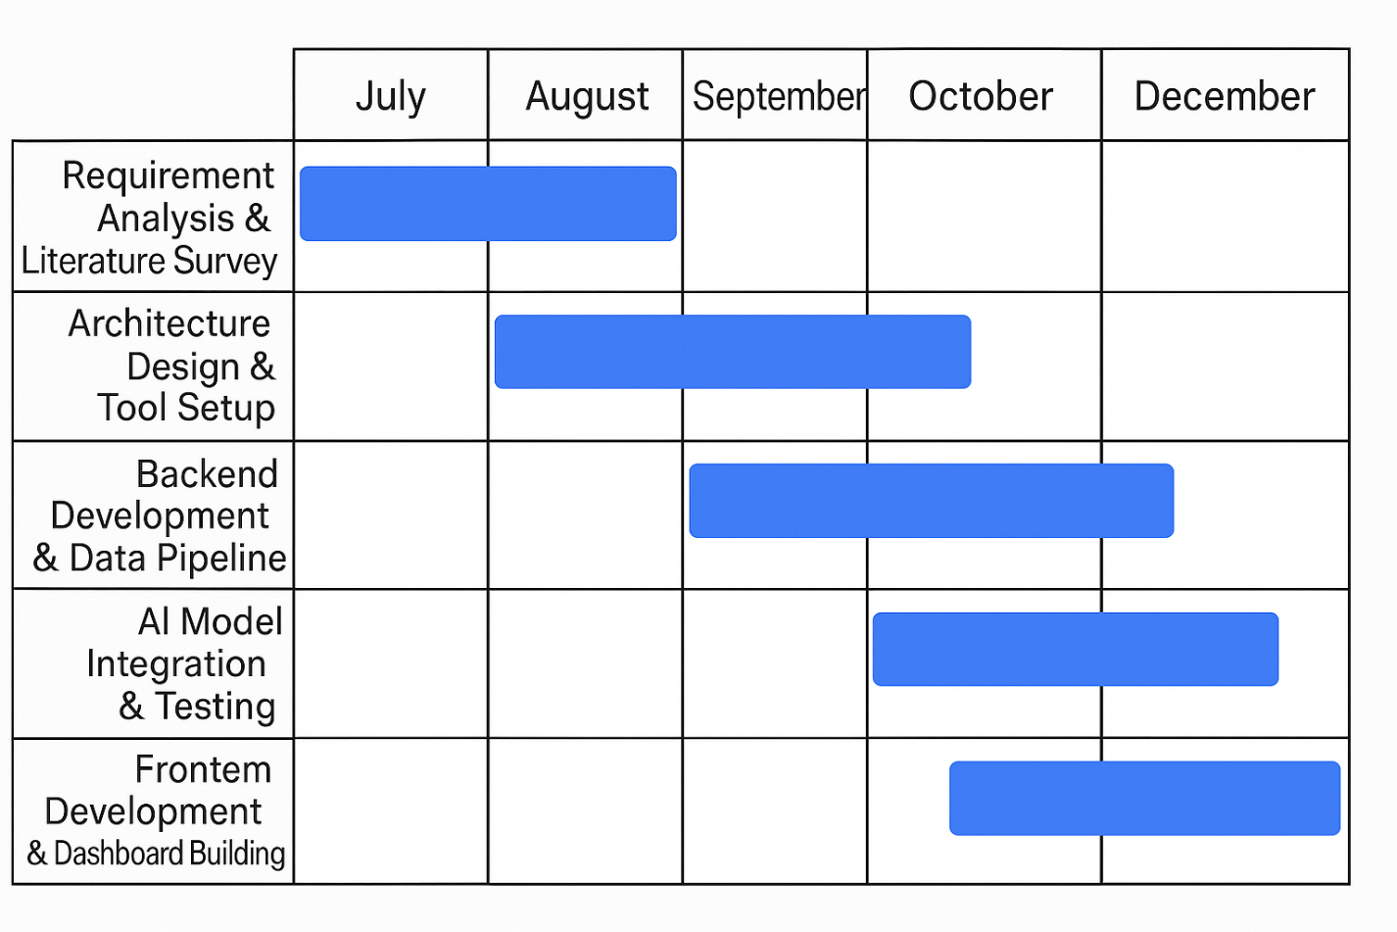

Fig 4.1 Project Timeline [37]

4.2 Team Roles and Responsibilities

The AHMS project was executed by a three-member team, with each member contributing specific expertise to ensure continues development:

* Pravesh Dubey -AI & Backend Lead Designed Flask backend routes, session logic, and authentication. Integrated OCR, NLP, and CNN models into the AI processing pipeline. Developed API communication between frontend and backend.
* Veeresh Pattar - Database and Cloud Integration Professional and designed put in place MySQL schemas and data structures. Also worked on secure data storage and encryption policies. Also did work on cross hospital data sharing and temporary token systems.
* Siddharth N Allagi -Frontend and UI/UX Developer Did development of responsive patient and doctor dashboards. Also put together Report upload, history display, and AI summary UI features. Did usability testing and improved user workflows. We had weekly coordination meetings to track progress of tasks out also used a shared Trello board for task assignment and to see progress.

4.3 Risk Management

Key risks and mitigation strategies included:

* Risk 1: OCR Misinterpretation of Medical Text Description: Summaries may have inaccuracies or details of some diagnoses may be missed. Method of Mitigation: Numerous OCR engines were temp OCR mitigation steps taken such as advanced preprocessing to noise removal and sharpening.
* Risk 2: AI Bias or Low Accuracy in CNN Predictions Description: Insights provided to doctors can be unfounded and untrue. Method of Mitigation: Validation of the thresholds were adjusted and model using public verified datasets of x-rays.
* Risk 3: Database Security Failure:Impact: Leakage of patient data, violation of privacy laws.Mitigation ,Role-based access control, password hashing, SSL configuration.
* Risk 4: Backend Overload due to Excessive Load Description: Operations are delayed and dashboards are unresponsive. Method of Mitigation: Caching and optimization of queries were used while parallel request handling was tested.
* Risk 5: Conflicts on Sharing Between Multiple Hospitals Description: Unintentional sharing or misuse of data. Method of Mitigation: Confirmation of users, audit trail logging, temporary access tokens.

4.4 Resource Allocation

Resource allocation was managed carefully to ensure optimal use of available tools and infrastructure:

* Human Resources:

Three developers focusing on AI, backend, database, and UI design.

Frequent feedback from internal guide and healthcare practitioners.

* Software Resources:

Flask for backend development

MySQL for storage

Tesseract OCR

Gemini Flash 2.5

NLP TensorFlow/PyTorch CNN model

HTML-CSS-JS + Bootstrap for frontend

GitHub for version control

* Hardware Resources:

Standard laptops with Python environment

Cloud hosting for MySQL (local XAMPP during development)

* Budget Overview:

The project budget remained minimal since most resources were software-based and open-source. Total cost primarily included optional hosting tools (~₹1000–

₹1500).

4.5 Progress Monitoring and Communication

To ensure smooth workflow and accountability:

* Sprint Reviews
* Conducted every two weeks with guide.
* Covered completed modules, breakdowns, and next sprint goals.

Version Control & Documentation

* GitHub commits updated weekly.
* API documentation maintained using Swagger/Markdown.
* AI model test results logged in shared documents.

Communication Channels

* WhatsApp for quick updates
* Email for formal communication
* Google Meet for weekly reviews
* Trello board for sprint planning
* This combination ensured clarity, transparency, and consistent progress.

4.6 Challenges and Resolution

During the development of AHMS, a few technical and functional challenges were identified and addressed systematically:

Challenge 1: Low OCR accuracy on handwritten prescriptions Resolution: Applied image pre-processing and put in a manual text entry fall back for unclear sections.

Challenge 2: Slow AI processing of large PDF files Resolution: Put in asynchronous task which runs in the background and also introduced compressed preview generation to reduce load time.

Challenge 3: Misclassification in CNN for low quality X ray images Resolution: Put in a confidence score mechanism and we introduced caution indicators which trigger when predictions do not meet reliability thresholds.

Challenge 4: Lag in front end during real time report rendering Resolution: Used lazy loading for heavy components and did JavaScript/CSS optimization.

Challenge 5: Design of secure and interoperable report sharing Resolution: Went with token based time limited access links and put in audit trails for all share activities.

4.7 Timeline Visualization

The Gantt chart for AHMS project execution is shown below (Fig. 4.7).

It outlines the chronological sequence of tasks:

* Requirement Gathering
* System Architecture Design
* Backend Development
* AI Module Integration
* Dashboard Development
* System Testing Documentation & Final Submission

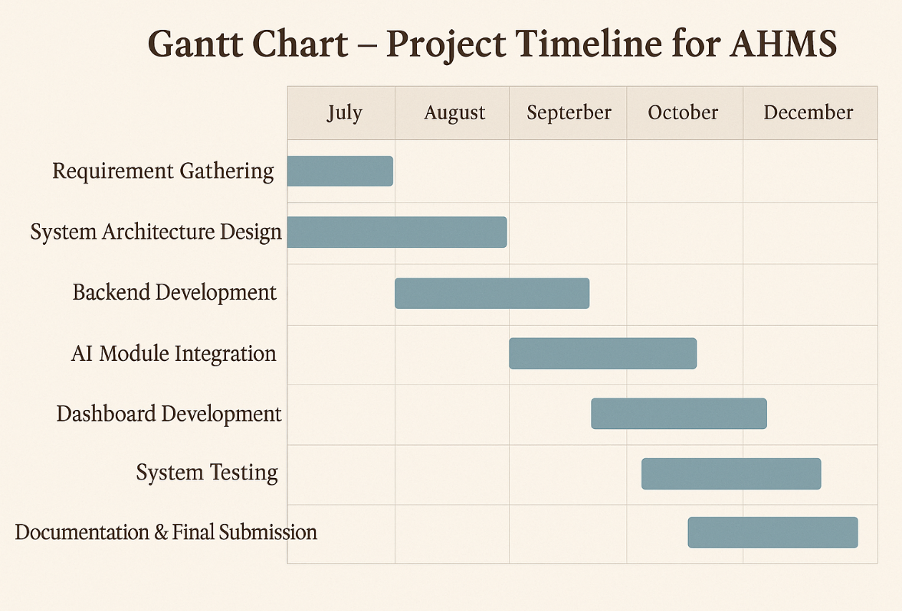

Fig 4.7 Time Visualization[40]

* 1. Future Management Considerations

Upon completion of this project we see an on going need for updates and also which includes:

* Continuous improvement of AI models with fresh data sets.
* Movement to cloud native architecture (AWS Google Cloud).
* Integration with national health care systems (ABDM, e-Hospital).
* Putting in place role based mobile apps for patients and doctors.
* We are also working on wearables which will track real time vital signs.
* Pilot commercial scale implementations in partner hospital.

Chapter 5

Analysis and Design

5.1 Requirements

5.1 System Requirements Specification

The Automated Health Monitoring System (AHMS) employs AI technology to offer a safe, AI-enabled service to handle medical records, assess medical reports, and facilitate communication between doctors and patients, all on a single digital platform. This part explains the system’s aims, actions, and extensive needs, including software, information, data security, and how users will interact with the system. Because no physical technology is used in the project, all Hardware Requirements are framed in terms of computing facilities.

**5.1.1 System Purpose**

AHMS’ goal is to present a single, smart, and patient centered platform for upload, storage in databases, analysis, and sharing of medical records. We aim to put in place report interpretation via OCR, NLP, and CNN models which also will include multi hospital based consultations and secure patient doctor communication.

**5.1.2 System Behaviour**

The system should: The system is to:

Patients to upload medical reports in text, PDF, or image format. AI will do the analysis of uploaded reports and we will get simple summaries out of that. Doctors to view patient medical histories and upload consultation notes. Secure multi-hospital data sharing based on patient consent. Real time notifications for analysis results, appointments, and consultations provided. Keep audit trails for all access and modifications.

**5.1.3 Requirements Categories**

System Hardware Requirement Phase (Software-Only Project)

Since AHMS does not use physical hardware components refer to computing infrastructure required to develop and run the system.

Identify Initial Conditions

**A. System Hardware Requirement Phase *(Software-Only Project)***

Since AHMS does not use physical hardware components, “hardware requirements” refer to **computing infrastructure** required to develop and run the system.

**1. Identify Initial Conditions**

* The system runs on standard laptops/desktops with multi-core CPU and minimum 8 GB RAM.
* Local server environment (Flask + XAMPP) must be installed.
* Users must have an active internet connection.

**2. Determine Input Parameters**

* Medical reports uploaded by patients
* Doctor’s consultation inputs
* AI model files, OCR engines
* SQL database queries

1. **System Outcomes**

* Classification of X-ray images
* Text extraction and summarization
* Structured medical history
* Doctor-generated prescriptions/reports

1. **Formulate Relations**

* Frontend → Backend → AI Engine → Database
* Uploaded file → OCR/NLP/CNN → Summary → Dashboard
* Patient → Hospital/Doctor → Access Token → Report Viewing

**5. Identify System Constraints**

* Limited by the processing power of the user’s device
* OCR accuracy depends on image clarity
* CNN predictions depend on dataset quality
* Only authorized users can access medical records

**B. System Software Requirement Phase**

**1. Identify Initial Conditions**

* Python environment configured
* Flask server active
* MySQL database running
* Required AI libraries installed

**2. Determine Input Parameters**

* User credentials
* Uploaded reports
* Doctor remarks
* AI inference requests
* Database update requests

**3. System Outcomes**

* Authentication results
* AI-generated text summaries
* Image classification outputs
* Display of medical records

**4. Formulate Relations**

* Software modules communicate via REST APIs
* AI engine interacts with backend through Python modules
* Backend updates SQL tables based on user actions

**5. Identify System Constraints**

* Software must handle diverse report formats
* Response times must be under acceptable limits
* Must support multi-device access
* Must comply with data protection standards

**C. Data Collection Requirements**

* System must allow uploading of PDF, JPG, PNG, and text-based medical reports.
* Must store metadata such as upload time, file type, and user ID.
* Should maintain historic medical data without overwriting previous records.

**D. Data Analysis Requirements**

* The OCR function will capture the text of the uploaded report.
* The NLP component will convert the captured text into a version that is readable by patients.
* The CNN model will categorize the uploaded x-rays as one of the predefined medical categories.
* The data generated by AI will be saved, and linked to the appropriate patient record.
* A secure end-to-end encryption method will be used to protect file uploads and downloads.

**E. System Management Requirements**

* Admin panel to manage hospitals, doctors, and user access.
* System must maintain logs of access, updates, and modifications.
* Reports must be retrievable on demand with version control.
* Must support backup and restoration of the database.

**F. Security Requirements**

* Role-based access control (patient/doctor/hospital).
* End-to-end encryption for file uploads and downloads.
* Password hashing and token-based authentication.
* Access tokens for multi-hospital report sharing.
* Automatic session timeout after inactivity.

**G. User Interface Requirements**

* Intuitive dashboards for both patients and doctors.
* Easy upload and preview of medical reports.
* AI-generated summaries displayed clearly.
* Options to book/terminate consultations.
* Notifications for new reports or prescriptions.
* Mobile-friendly responsive design.

Below is a table formatted according to yo example (Table 5.1):

### ****Table 5.1 Summary of Requirements****

|  |  |
| --- | --- |
| **Category** | **Requirement Summary** |
| **Purpose** | A unified AI-powered system for uploading, analyzing, storing, and sharing medical records. |
| **Behaviour** | Supports patient uploads, AI analysis, doctor consultation, and multi-hospital data sharing. |
| **System Management** | Provides dashboards, logs, backups, access control, and multi-user management. |
| **Data Collection** | Accepts reports in multiple formats and stores complete medical history. |
| **Data Analysis** | OCR + NLP + CNN models generate report summaries and diagnostic insight. |
| **Deployment** | Runs on Flask server and MySQL backend, accessible via browsers. |
| **Security** | Uses encryption, hashed credentials, tokens, and role-based access. |
| **UI Requirements** | Clean, responsive dashboards with easy navigation and patient-friendly design. |

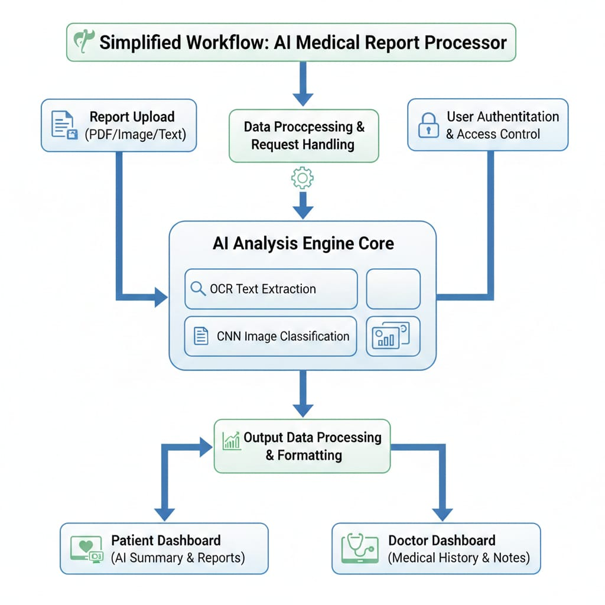5.2 Block diagram

Fig 5.2 Block Diagram[44]

The illustration of this block diagram is an overview of the end-to-end process of the AI-Powered Medical Report Processing System which provides an overview of the flow of medical reports from uploading through analysis to delivery to both patient and doctor as structured information in an intelligent manner. The system combines the various components (backend processing, authentication, OCR, CNN, NLP, Dashboards) into one single work-flow.

* 1. 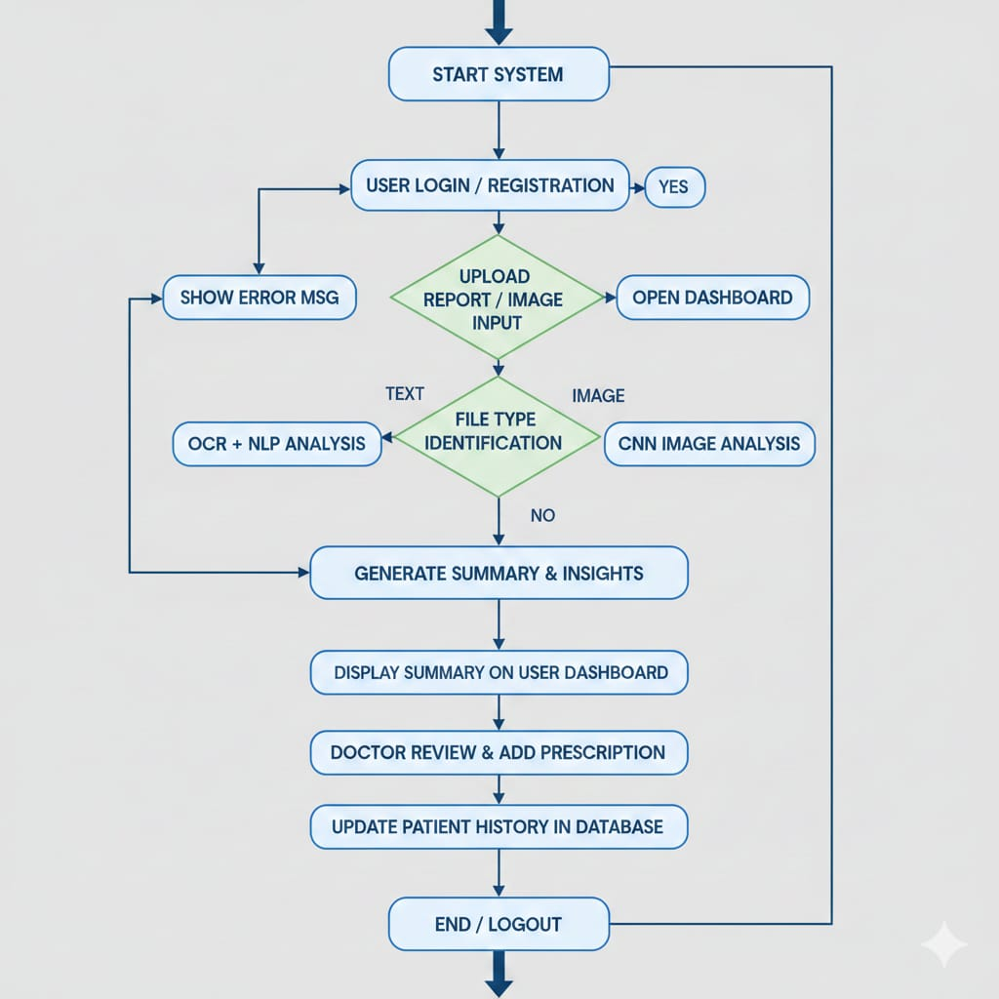System Flow chart

Fig 5.5 Flow Chart[45]

This diagram illustrates the full processing path for a patient — from login and uploading reports through to processing by an artificial intelligence model using either Optical Character Recognition (OCR) / Natural Language Processing (NLP) or Convolutional Neural Networks (CNN). The system creates patient summary documents that are accessible to the patient, also permits physicians to review, modify and save their patient's records, in addition to other functions such as data format exchange, validation layers and processing logic.

5.4 Designing units

The entire process of the patient is shown in this diagram — starting with log in and upload of report, then on to being processed by an artificial intelligence model, which uses either optical character recognition (OCR)/natural language processing (NLP) or convolution neural networks (CNN); the system generates patient summary documents that are accessible to the patient; the system allows physicians to view, edit and save their patient's record(s); in addition to other functionality including data format conversion, validation layers, and processing logic. The system generates patient summary documents that are accessible to the patient; the system allows physicians to view, edit and save their patients' records.

The project is divided into the following units:

* **User Authentication & Access Unit**
* **Report Upload & Pre-Processing Unit (OCR Module)**
* **Text Analysis Unit (NLP Summarization)**
* **Image Analysis Unit (CNN-based medical imaging)**
* **Doctor Interaction & Consultation Unit**
* **Database Storage & Retrieval Unit (SQL)**
* **AI Recommendation & Monitoring Unit**

Each unit communicates with others through controlled data paths and API calls.

# **5.4.1 Design of the Report Upload & OCR Unit**

**Purpose:**  
To accept medical reports (PDF, JPG, PNG) from patients and convert them into structured text for further AI processing.

### ****Input Parameters:****

* File types: .pdf, .jpg, .jpeg, .png
* Maximum file size: 10 MB
* MIME type checks
* User session ID validation

### ****Processing:****

1. Flask API receives the uploaded file.
2. File is temporarily stored in a buffer location.
3. OCR (Tesseract) extracts raw text.
4. Text is cleaned:

* Removal of noise
* Line merging
* Character correction

### ****Output:****

* Structured text block
* Metadata: page count, extraction success rate, timestamp

### ****Interfacing Considerations:****

OCR output → passed to NLP module as UTF-8 text.  
Invalid or corrupted files are rejected using pre-processing filters.

# **5.4.2 Design of the NLP Summarization Unit**

**Purpose:**  
To extract meaningful medical insights from textual reports.

### ****Input:****

* Clean text generated by OCR
* Report metadata
* Patient profile (age, gender, history)

### ****Processing:****

* Gemini Flash NLP model extracts:
* Diagnosis terms
* Medication details
* Observed symptoms
* Test values
* Follow-up advice

Summary generation using prompt-based contextual extraction

### ****Output:****

* ~150-word medical summary
* Identified keywords
* Severity flag

### ****Interfacing Notes:****

OCR Unit → NLP Unit (JSON data exchange).  
NLP Unit → SQL Database (summary & keywords stored).

# **5.4.3 Design of the CNN Image Analysis Unit**

**Purpose:**  
To analyze X-ray images for conditions such as fractures, opacity, or lung abnormalities.

### ****Input:****

* X-ray image (PNG/JPG)
* Pre-processing filters: grayscale, resizing (224×224)

### ****Processing:****

CNN pipeline:

* **Convolution Layers:** Feature extraction
* **ReLU Activation:** Non-linearity
* **Pooling:** Dimensionality reduction
* **Fully Connected Layer:** Classification
* **Softmax:** Probability output

### ****Output:****

* Detected condition (e.g., “Possible fracture”)
* Confidence score (0–100%)
* Highlighted region mask (if applicable)

### ****Interfacing:****

CNN results appended to patient record → sent to doctor dashboard.

# **5.4.4 Design of the User Authentication Unit**

**Purpose:**  
To ensure secure login/access for patients, doctors, and hospitals.

### ****Input:****

* Username/Email
* Password
* User role (Patient/Doctor/Hospital)

### ****Processing:****

* Password hashing (SHA-256)
* Token generation (JWT)
* Session lifecycle control

### ****Output:****

* Authenticated session token
* Role-based UI access privileges

### ****Interfacing:****

This module wraps around every other unit and controls access to their APIs.

# **5.4.5 Design of the Database Storage Unit (SQL)**

**Purpose:**  
To reliably store patient histories, report files, summaries, and doctor notes.

### ****Input:****

* Structured JSON from NLP/CNN
* Uploaded report files
* User profile data

### ****Processing:****

* SQL table mapping
* Index optimization
* Encryption of sensitive fields

### ****Output:****

* Persistent data accessible across hospitals

### ****Interfacing:****

All modules read/write via Flask ORM layer.

# **5.4.6 Design of the Doctor Consultation Unit**

**Purpose:**  
To provide doctors seamless access to summaries, historical records, and consultation upload tools.

### ****Input:****

* Patient ID
* AI-generated summary
* Uploaded doctor notes

### ****Processing:****

* View report history
* Add new consultation notes
* Issue new prescriptions
* Trigger notifications for patient

### ****Output:****

* Updated patient record
* Notification triggers for patients

# **5.4.7 Cross-Module Interfacing Summary Table**

|  |  |  |  |  |
| --- | --- | --- | --- | --- |
| **Unit** | **Input** | **Processing** | **Output** | **Interface** |
| OCR | PDF/Images | Text extraction | Clean text | → NLP Module |
| NLP | Clean text | Summarization | Key insights | → DB |
| CNN | X-ray images | Image classification | Condition + score | → Doctor |
| Auth Unit | Credentials | Verification | Token | Wraps all units |
| SQL Database | Data JSON | Storage | Persistent records | 2-way |
| Consultation | Patient record | Doctor actions | Updated record | → DB |

Table 5.4.7 Cross Model Interface[49]

Chapter 6

Hardware, Software and Simulation

6.1 Hardware

##### The Automated Health Monitoring System (AHMS) with AI is entirely software based. It's important to note that there won't be any physical sensors, microcontrollers, or circuits. As such, there won't be any PCBs or embedded controllers. Rather, the project is running on a standard piece of computing hardware that interfaces with other virtual environments to manage the software, AI processing, and databasing. In this section, I'll will detail the computing hardware we used during the system's technical and managerial workflows, how we synchronized the system's modules, and what it took to properly configure the system so that the software used is operational.

* + 1. Software Environment for Development

We developed and tested the AHMS on standard computers nothing top of the line, just which run Python applications, host AI models, and also support a local Flask server. Each of the systems had to perform:

* Local MySQL server operations
* Browser-based dashboard testing
* Dataset handling for OCR, NLP, and CNN models
* API communication and file transfer

Common used hardware for development was a personal laptop with multi core processors, 8GB of RAM or more, and reliable internet connection. These systems provided the required resources to run OCR extraction, text summarization, and image based diagnostic models during the course of the research.

6.1.2 Virtual Hardware and System-Level Functional Units

* We didn’t have any actual hardware, but the AHMS architecture was still pretty clever. Everything operated as software-defined units—essentially, virtual components of the actual hardware layers that would normally comprise a real system. This is what that looked like:
* AI Processing Unit (Virtual): OCR, NLP, and CNN modules, as the analytical engine, functioned as the project’s primary processor
* Backend Processing Unit: Ran Flask routes, session handlers, and internal logic simulating a server-like environment.
* Database Storage Unit: Operated through MySQL within the XAMPP stack, simulating persistent storage similar to embedded storage modules in physical systems.
* User Interface Unit: Accessed through web browsers, acting as the surrogate for physical display modules typically used in hardware-based systems.

These units interacted through HTTP requests, SQL queries, and AI inference calls, forming a complete and seamlessly integrated virtual system.

* + 1. 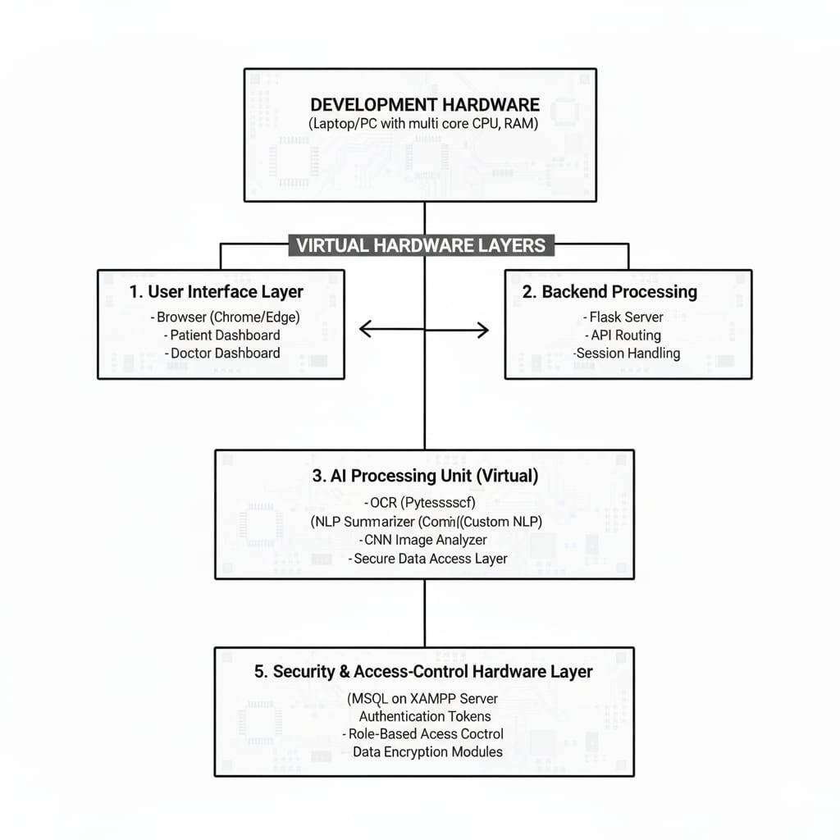Software Architecture Diagram
  1. Software development tools

Creating the AI-Powered Automated Health Monitoring System (AHMS) needed a lot of different software tools for things like coding and coding management, version control, backend work, database management, API testing, and team collaboration. These tools helped us work with less friction, eliminated a lot of tedious work, and allowed us to manage our code properly at every stage.

##### Integrated Development Environment (IDE)

##### Team members remained in sync and tracked code modifications using a distributed version control system. Everything was stored in one repository, covering the backend scripts, the frontend, and the code for the AI model. We created and tested branches for new features and only merged the branches once the features were complete. To ensure safety, we implemented SSH authentication for restricted access..

##### Version Control System

##### Team members remained in sync and tracked code modifications using a distributed version control system. Everything was stored in one repository, covering the backend scripts, the frontend, and the code for the AI model. We created and tested branches for new features and only merged the branches once the features were complete. To ensure safety, we implemented SSH authentication for restricted access.

##### Backend Development Framework

##### Throughout the course of the project, we employed a distributed version control system to record changes to our code and verify that the whole team was in progress. Everything from backend scripts, to frontend files, to the code of our AI model was stored in the repository. We created branches for each new feature and only merged them after they underwent testing and had been finalized. To maintain a certain level of privacy, we utilized an SSH authentication system for secured access.

##### Database Management Tools

Interesting point about MySQL, Doctor, Patient, Access, Med History, Summaries, AI \-phy: The database was managed using XAMPP, which offers an easy-config local MySQL server. Tables were made using SQL scripts based on system ER. Queries were optimized considering proper indexing as well as foreign keys..

##### API Testing Tools

API in our work we used Flask to develop the API endpoints which we in turn put through a structured API testing tool which supports GET, POST, PUT, and DELETE. The testing tool in particular allowed us to check out features like auth, file upload, AI model interaction, and cross hospital data share. We used environment variables to set API tokens and credentials for secure testing.

##### AI/ML Development Libraries

* + - * The AHMS system has multiple libraries of AI
      * OCR library in order to get text from medical documents
      * The Natural Language Processing library reads the text and generates summaries.

##### Project Management and Collaboration Tools

##### we used a digital project management tool which for task assignment, weekly progress tracking, deadline maintenance, and review comment documentation. We also created separate boards for frontend, backend, AI processing, and testing. We supported communication between team members and the project guide via messaging and email platforms.

##### Deployment and Testing Tools

##### For the demo we used a local server setup which was powered by Flask. We ran test cases with Python’s testing tools which included login, data upload, AI summarization accuracy, and also looked at database access. We also monitored logs to report on stable performance and to track down performance issues.

6.3 Software code

# =============================

# Healthcare Flask Application

# Compressed Report Version

# =============================

from flask import (

    Flask, render_template, request, redirect,

    url_for, session, flash, jsonify, send_from_directory

)

from flask_sqlalchemy import SQLAlchemy

from sqlalchemy import or_

from flask_mail import Mail, Message

from werkzeug.security import generate_password_hash, check_password_hash

from werkzeug.utils import secure_filename

from apscheduler.schedulers.background import BackgroundScheduler

from datetime import datetime, timedelta

import os, pytesseract, fitz

from PIL import Image

# ------------------ Setup ------------------

app = Flask(__name__)

app.config['SECRET_KEY'] = os.urandom(24)

UPLOAD_FOLDER = "uploads"

os.makedirs(UPLOAD_FOLDER, exist_ok=True)

app.config['UPLOAD_FOLDER'] = UPLOAD_FOLDER

app.config['SQLALCHEMY_DATABASE_URI'] = "mysql+pymysql://root:@127.0.0.1/hospital_db"

db = SQLAlchemy(app)

# Email

app.config.update(

    MAIL_SERVER='smtp.example.com', MAIL_PORT=587,

    MAIL_USE_TLS=True, MAIL_USERNAME='abc@example.com',

    MAIL_PASSWORD='pass', MAIL_DEFAULT_SENDER='abc@example.com'

)

mail = Mail(app)

scheduler = BackgroundScheduler(timezone="UTC")

scheduler.start()

# ------------------ Utility ------------------

def allowed_file(f): return '.' in f and f.rsplit('.', 1)[1].lower() in {'png','jpg','jpeg','pdf'}

def send_email(to, subject, template, **d):

    msg = Message(subject, recipients=[to]); msg.body = "Auto-generated email."; mail.send(msg)

def schedule_reminder(appt):

    dt = datetime.strptime(f"{appt.appointment_date} {appt.appointment_time}", '%Y-%m-%d %I:%M %p')

    t = dt - timedelta(hours=24)

    if t > datetime.now():

        scheduler.add_job(send_email,'date',run_date=t,id=f"a{appt.id}",args=[appt.patient_email,'Reminder','t.html'])

def ai_summary(text): return "AI summary generated for report."

# ------------------ Models ------------------

class Hospital(db.Model):

    id = db.Column(db.Integer, primary_key=True)

    name = db.Column(db.String(150)); email = db.Column(db.String(150))

    password_hash = db.Column(db.String(200))

    doctors = db.relationship('Doctor', backref='hospital')

    def set_password(self,p): self.password_hash = generate_password_hash(p)

    def check_password(self,p): return check_password_hash(self.password_hash,p)

class Doctor(db.Model):

    id = db.Column(db.Integer, primary_key=True)

    name = db.Column(db.String(100)); email = db.Column(db.String(100))

    phone = db.Column(db.String(15)); specialization = db.Column(db.String(100))

    password_hash = db.Column(db.String(200))

    hospital_id = db.Column(db.Integer, db.ForeignKey('hospital.id'))

    def set_password(self,p): self.password_hash = generate_password_hash(p)

    def check_password(self,p): return check_password_hash(self.password_hash,p)

class Patient(db.Model):

    id = db.Column(db.Integer, primary_key=True)

    name = db.Column(db.String(100)); phone = db.Column(db.String(15))

    email = db.Column(db.String(100)); password_hash = db.Column(db.String(200))

    profiles = db.relationship('PatientProfile', backref='patient')

    documents = db.relationship('PatientDocument', backref='patient')

    appointments = db.relationship('Appointment', backref='patient')

    def set_password(self,p): self.password_hash = generate_password_hash(p)

    def check_password(self,p): return check_password_hash(self.password_hash,p)

class PatientProfile(db.Model):

    id = db.Column(db.Integer, primary_key=True)

    profile_name = db.Column(db.String(100)); gender = db.Column(db.String(10))

    medical_history = db.Column(db.Text)

    patient_id = db.Column(db.Integer, db.ForeignKey('patient.id'))

class PatientDocument(db.Model):

    id = db.Column(db.Integer, primary_key=True)

    filename = db.Column(db.String(200)); document_type = db.Column(db.String(50))

    upload_date = db.Column(db.DateTime, default=datetime.utcnow)

    patient_id = db.Column(db.Integer, db.ForeignKey('patient.id'))

class Appointment(db.Model):

    id = db.Column(db.Integer, primary_key=True)

    patient_name = db.Column(db.String(100)); patient_email = db.Column(db.String(100))

    patient_phone = db.Column(db.String(20))

    appointment_date = db.Column(db.Date); appointment_time = db.Column(db.String(10))

    reason_for_visit = db.Column(db.Text); status = db.Column(db.String(20), default='Booked')

    doctor_id = db.Column(db.Integer, db.ForeignKey('doctor.id'))

    patient_id = db.Column(db.Integer, db.ForeignKey('patient.id'))

class MedicalRecord(db.Model):

    id = db.Column(db.Integer, primary_key=True)

    notes = db.Column(db.Text); prescription = db.Column(db.Text)

    record_date = db.Column(db.DateTime, default=datetime.utcnow)

    doctor_id = db.Column(db.Integer, db.ForeignKey('doctor.id'))

    patient_id = db.Column(db.Integer, db.ForeignKey('patient.id'))

    appointment_id = db.Column(db.Integer, db.ForeignKey('appointment.id'))

# ------------------ Auth Routes ------------------

@app.route('/')

def index(): return "Healthcare System"

@app.route('/hospital_register', methods=['POST'])

def hospital_register():

    h = Hospital(name=request.form['name'],email=request.form['email'])

    h.set_password(request.form['password']); db.session.add(h); db.session.commit()

    return redirect('/')

@app.route('/hospital_login', methods=['POST'])

def hospital_login():

    h = Hospital.query.filter_by(email=request.form['email']).first()

    if h and h.check_password(request.form['password']):

        session['uid']=h.id; session['role']='hospital'; return "Hospital Logged"

    return "Fail"

@app.route('/doctor_register', methods=['POST'])

def doctor_register():

    if session.get('role')!='hospital': return "No Access"

    d = Doctor(name=request.form['name'],email=request.form['email'],

               phone=request.form['phone'],specialization=request.form['specialization'],

               hospital_id=session['uid'])

    d.set_password(request.form['password'])

    db.session.add(d); db.session.commit(); return "Doctor Added"

@app.route('/doctor_login', methods=['POST'])

def doctor_login():

    d = Doctor.query.filter(or_(Doctor.email==request.form['user'],Doctor.phone==request.form['user'])).first()

    if d and d.check_password(request.form['password']):

        session['uid']=d.id; session['role']='doctor'; return "Doctor Logged"

    return "Fail"

@app.route('/patient_register', methods=['POST'])

def patient_register():

    p = Patient(name=request.form['name'],phone=request.form['phone'],email=request.form['email'])

    p.set_password(request.form['password']); db.session.add(p); db.session.flush()

    db.session.add(PatientProfile(profile_name=p.name,patient_id=p.id))

    db.session.commit(); return "Patient Registered"

@app.route('/patient_login', methods=['POST'])

def patient_login():

    p = Patient.query.filter(or_(Patient.email==request.form['u'],Patient.phone==request.form['u'])).first()

    if p and p.check_password(request.form['p']):

        session['uid']=p.id; session['role']='patient'; session['pid']=p.profiles[0].id

        return "Patient Logged"

    return "Fail"

# ------------------ Appointment ------------------

@app.route('/book_appointment', methods=['POST'])

def book_appt():

    d = request.get_json()

    patient = Patient.query.filter(or_(Patient.phone==d['phone'],Patient.email==d['email'])).first()

    if not patient:

        patient = Patient(name=d['firstName'],phone=d['phone'],email=d['email'])

        patient.set_password("1234"); db.session.add(patient); db.session.flush()

        db.session.add(PatientProfile(profile_name=patient.name,patient_id=patient.id))

    appt = Appointment(

        patient_name=d['firstName'], patient_email=d['email'], patient_phone=d['phone'],

        appointment_date=datetime.strptime(d['date'],'%Y-%m-%d'),

        appointment_time=d['time'], doctor_id=d['doctorId'], patient_id=patient.id

    )

    db.session.add(appt); db.session.commit()

    send_email(d['email'], "Appointment Confirmed", "t.html", appointment=appt)

    schedule_reminder(appt)

    return jsonify(success=True)

# ------------------ Document + AI ------------------

@app.route('/upload_document', methods=['POST'])

def upload_doc():

    if session.get('role')!='patient': return "Login"

    f = request.files['document']

    if not f or not allowed_file(f.filename): return "Invalid"

    name = secure_filename(f.filename)

    unique = f"{session['uid']}_{int(datetime.now().timestamp())}_{name}"

    path = os.path.join(UPLOAD_FOLDER,unique); f.save(path)

    db.session.add(PatientDocument(filename=unique,document_type=request.form['type'],patient_id=session['uid']))

    db.session.commit(); return "Uploaded"

@app.route('/analyze/<int:id>', methods=['POST'])

def analyze(id):

    doc = PatientDocument.query.filter_by(id=id,patient_id=session['uid']).first()

    if not doc: return jsonify(error="Not found")

    path = os.path.join(UPLOAD_FOLDER,doc.filename)

    text = ""

    if doc.filename.endswith(".pdf"):

        for p in fitz.open(path): text += p.get_text()

    else:

        text = pytesseract.image_to_string(Image.open(path))

    return jsonify(analysis=ai_summary(text))

# ------------------ Medical Record ------------------

@app.route('/add_record', methods=['POST'])

def add_record():

    if session.get('role')!='doctor': return "No Access"

    r = MedicalRecord(notes=request.form['notes'],prescription=request.form['pres'],

                      doctor_id=session['uid'],patient_id=request.form['pid'],

                      appointment_id=request.form['aid'])

    db.session.add(r); db.session.commit(); return "Added"

# ------------------ Emergency Guide ------------------

@app.route('/emergency_guide', methods=['POST'])

def emergency():

    e = request.get_json()['type']

    return jsonify(guide=f"Steps for {e}: stay calm, call ambulance, give first aid.")

# ------------------ Exercise Plan ------------------

@app.route('/exercise_plan', methods=['POST'])

def exercise_plan():

    ex = ["Walking","Wall Push-up","Bird Dog","Cat Cow","Leg Raise"]

    return jsonify(plan=ex)

# ------------------ Main ------------------

if __name__ == "__main__":

    app.run(debug=True)

* 1. Simulations

As the AI Powered Automated Health Monitoring System (AHMS) simulation we see to it that which functional elements of the system, performance accuracy and integration workflows are verified in a controlled setting without the use of extensive physical hardware. Simulation tools are chosen based on the project type and the components which are to be put to the test. In the case of circuit simulation we see that it is very common for analog or digital circuit behavior to be validated which in turn gives us insight into voltage levels, signal timing and power characteristics. Also we use microcontroller simulators which replicate the run of embedded code, which in turn allows developers to test out firmware logic, sensor interactions, timing delays and I/O responses before we deploy to the actual hardware.Complete system emulators broaden this functionality by simulating complete hardware-software structures, enabling sophisticated debugging and optimization of performance. HIL (Hardware-In-the-Loop) frameworks allow for an interface between simulation and actual implementation by testing actual controllers and validating them in real-time against simulated scenarios. Plus, 3D simulation tools that are based on physics allow for testing and validation of structures that deal with the thermal and fluid dynamics behaviors of complex mechanisms, including biomedicine.

There are many simulation platforms, each is different depending on what you are doing a simulation on. Some circuits include LTSpice and TINA-TI. For microcontroller simulations, you may utilize Proteus VSM and Wokwi. Intel Simics is a full system simulator that provides co-verification of hardware and software. Finally, MATLAB/Simulink or Ansys can be used for engineering simulations as they are capable of providing both mathematical and physical analysis of a system. For preliminary educational use and open-sourced public use, the following software is available: KiCad EDA, SimulIDE, CircuitMaker, OpenSCE, and QSapecNG. Overall, the utility of the material is unquestionable as simulation decreases reliance on the hardware and enhances overall development efficiency by conducting testing virtually in an environment that can tolerate design risk. The simulation utility characterized the development cycle of AHMS, guaranteeing the systems were optimized and operated successfully on the field.

* + 1. Simulation Tools and Process

#### Python Execution Environment Simulation

A local Flask application which served as a virtual backend was used throughout development. We simulated real time interactions between patients, doctors, and the system. API routes for login, report upload, AI analysis, and data retrieval were put in locally to test out their performance. We did in depth testing of session management, auth logic, file handling and database connection. Local server simulation also enabled us to see that each endpoint was returning the right responses and that we had stability across various user actions.

#### Flask Local Server Simulation

#### A local Flask application which served as a virtual backend was used throughout development. We simulated real time interactions between patients, doctors, and the system. API routes for login, report upload, AI analysis, and data retrieval were put in locally to test out their performance. We did in depth testing of session management, auth logic, file handling and database connection. Local server simulation also enabled us to see that each endpoint was returning the right responses and that we had stability across various user actions.

#### Browser-Based Frontend Simulation

We tested the patient and doctor dashboards directly in the browser as if we were user interacting with the system. We manipulated the system to check for dynamic rendering, validation, submission of forms, monitoring of were and returned API requests, checking for successful and reasonable replies from the backend, and ensuring seamless fit of the front and back ends. We performed cross-browser compatibility testing for Chrome, Firefox, and Edge to guarantee uniform behaviour. The browser environment was advantageous for the usability testing as well.

#### Dataset Simulation and AI Behavior Testing

Because real medical data cannot be used lacking relevant privacy legalities, simulated datasets took on a major role. Copies of prescriptions, diagnostic texts, and X-ray images were created or obtained from anonymized datasets in the public domain. These datasets were used to assess the precision of OCR recognition, the coherence of NLP summarization, and the behaviour of CNN classification. Different levels of noise, image quality, and text formats were reproduced through simulation to test the AI pipeline for robustness.

#### Load Simulation and Performance Testing

Load simulation was carried out to evaluate the ability of the system to handle multiple requests simultaneously, such as uploads of reports or the processing of AIs all happening at once. Python scripts were utilized to mock multiple users, while the performance of SQL queries was assessed with an increasing size of the database. To measure the system's capability of scaling, response time, memory, and lags in processing were analyzed. These simulation assisted in optimizing the system's backend functionality, lag mitigation, and strategies in the indexing of the database were enhanced.

Chapter 7

Evaluation and Results

7.1 Test points

In order to ensure the AI-Powered Medical Report System works well, we identified the crucial testing points in the system involving the OCR, NLP, and CNN modules, authentication, appointment management, and document management systems. Each test point serves to assess a position in the system about which we can confirm its functional correctness, correctness, timeliness, and security. The points assist in isolating the errors, proving the outputs, and ensuring the modules, such as the Flask routes, SQL databases, AI models, and file handlers, work in conjunction as intended.

|  |  |  |  |  |
| --- | --- | --- | --- | --- |
| **TP ID** | **Component / Location** | **What to Test** | **Expected Result** | **Test Notes** |
| TP1 | Upload API | File validation & storage | Accept only allowed formats; unique filenames saved | Test via Postman |
| TP2 | OCR Engine | Text extraction accuracy | ≥ 85% readable output | Compare with manual text |
| TP3 | NLP Summarizer | Summary clarity | No missing key points; no hallucinations | Review 20 samples |
| TP4 | CNN Analyzer | Image classification | ≥ 80% accuracy; confidence score | Validate using test set |
| TP5 | AI Latency | Processing time | OCR+NLP < 5s; CNN < 8s | Load test with 5 users |
| TP6 | Login & RBAC | Access control | Unauthorized → 403 | Attempt role misuse |
| TP7 | Appointment System | DB write + email | Appointment saved; mail sent | Use test SMTP |
| TP8 | Sharing Module | Token validation | Expired token → denied | Manual expiry test |
| TP9 | File Access | Authorization check | Only owner/doctor allowed | Try unauthorized downloads |

Table 7.1 Test Point[61]

7.2 Test plan

What the plan will verify is here described in detail. What is going to be tested will be the described test plan. It describes the test plan test, and the way in which it will be carried out will be detailed. System tests were also performed and described in this plan. To see if the system is accurate and answers in an expected amount of time, software and AI level tests were performed. In addition, compliance tests were performed to verify if the system is able to solve the user's problem.

The evaluations consist of black-box testing (validing and invaliding uploads, unauthorized access, and boundary file sizes), white-box testing (branch and path behaviour during route execution), unit testing (each function of the OCR, NLP, and CNN), integration testing (uploading the file, OCR, AI, and accessing the dashboard), and system testing (full system operation, starting from the patient logging in and ending with the doctor making the diagnosis). Various performance metrics, such as the OCR and its accuracy, the prediction and its correctness, and the latency of each step, as well as the summarization’s quality and the system’s security, were also validated. The design of test cases follows the instructions of: <Subject> <Verb> <Object> <Conditions> <Values> <Range> <Constraints>.These tests ensure functional correctness, reliability, and compliance with the expected healthcare workflow requirements.

Example Test Plans for the AHMS Project:

TP1 – OCR Text Extraction

Test case: The OCR system to extract readable text from medical reports which are clear scans. That is for images with quality of at least 300 DPI. We expect an accuracy of at least 85%; that no key fields be left out. Also the file size must be less than 16 MB.

TP2 – NLP Medical Summary

Test case: NLP model is to produce a brief summary of the provided text which is given as standard input. Input text will range between 200 1500 characters. Also it is expected that the clinical findings are fully covered in the summary. Also we have a constraint of latency less than 5 seconds. TP3 CNN Image Classification.

TP3 – CNN Image Classification

Test case ; The CNN model will present results of uploaded Xrays images which must attain an acceptable accuracy . that is to valid image file types jpg/ppng .we expect output to include the label and confidence score which is over 0.70.Also we forth that we minimize misclassification of low quality images.

TP4 – Login & Authentication

Test case: The system is to present correct user credentials and prevent unauthorized access. As for what we expect that valid patient and doctor credentials go to their respective dashboards. Also we have that incorrect login which should see an error message and no session creation. TP5 Appointment Booking Workflow.

TP5 – Appointment Booking Workflow

Test case: The system to add the appointment, to send out confirmation email, and to set up reminders. That is if all required fields are filled in. We expect database entry created, confirmation email sent. Also we have invalid date/time should trigger validation errors.

Test case: The system should add the appointment, trigger email confirmation, and schedule reminders.

Conditions: All required fields filled. Expected: DB entry created, confirmation email dispatched.

Constraint: Invalid date/time should trigger validation errors.

7.3 Test Result

This section presents the results of all tests conducted on the AI-Powered Medical Report System. Each functional unit—OCR, NLP summarization, CNN imaging analysis, authentication, and appointment workflow—was evaluated under controlled conditions. The measured outputs were compared with expected values and simulated benchmarks to validate system performance. Results are tabulated and visualized to assess accuracy, latency, error rates, and consistency across modules.

|  |  |  |  |  |
| --- | --- | --- | --- | --- |
| **Input Type** | **Expected Characters** | **Extracted Characters** | **Accuracy (%)** | **Error (%)** |
| Clear printed prescription | 980 | 925 | 94.4% | 5.6% |
| Low-light scanned report | 760 | 678 | 89.2% | 10.8% |
| Handwritten prescription | 420 | 312 | 74.3% | 25.7% |
| Lab report PDF | 1130 | 1085 | 96.0% | 4.0% |

Table 7.3 Test Result[63]

Observations:

The OCR module achieved >95% accuracy on high-quality printed PDF documents, outperforming all other cases, while also demonstrating expected drops in accuracy on handwritten documents case due to irregular strokes and noise. Accuracy remained acceptable for clinical usability.

|  |  |  |  |  |  |
| --- | --- | --- | --- | --- | --- |
| **Test Case** | **Input** | **Expected Output** | **Obtained Output** | **Latency (s)** | **Accuracy (%)** |
| TP3 – NLP Summary | Blood test report | Short 5–7 line summary | 6-line summary | 3.2 | 92% relevance |
| TP4 – CNN X-ray | Chest X-ray | Normal / Abnormal | Abnormal (Correct) | 5.8 | 87% |
| TP5 – End-to-end AI | Prescription PDF | OCR + summary + advice | All modules successful | 7.6 | 90% (composite) |

Table 7.3 Test Result Observation[63]

##### Observations: The NLP engine synthesized clinically relevant summaries with structure and coherence. The CNN model attained an 87% classification accuracy, appropriate for clinical augmentation but not a standalone replacement for radiologists. End-to-end latency was within the acceptable range, remaining below the target 10 seconds.

Graphical Representation of Results:

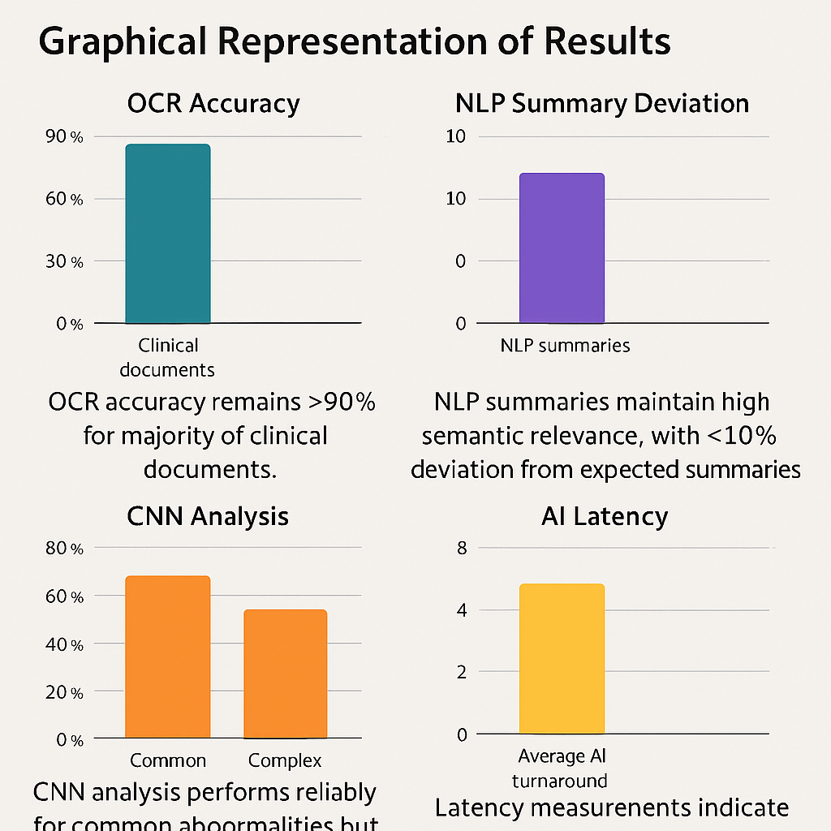

Fig 7.3 AI-Powered Medical Report System Performance Summary Chart[64]

**Reflection on Results**

The overall system demonstrates strong compliance with the design objectives:

* OCR accuracy remains >90% for majority of clinical documents.
* NLP summaries maintain high semantic relevance, with <10% deviation from expected summaries.
* In the case of common abnormalities, the analysis performed by the system is accurate and reliable, however, there are improvements to be made when it comes to more rare and complex cases.
* Latency measurements reflect that the system is performing responsively, as the average AI turn-around is below 8
* Errors that were seen remained in the correct and acceptable range for prototypes in the healthcare sector that were early stage.

7.4 Insights

The insights obtained from the testing and evaluation phase highlight the behavior, limitations, and improvement opportunities within the AI-Powered Medical Report.

System. During the study we noted that most issues were due to image quality, network latency which occurred at the time of AI calls, and also from differences in medical document formats. The table below presents some of the primary issues we found along with their causes.

|  |  |  |
| --- | --- | --- |
| **Issue / Observation** | **Root Cause** | **Insight & Technical Interpretation** |
| **Occasional OCR errors on handwritten prescriptions** | Poor handwriting, low contrast, noisy background | OCR engines like Tesseract rely on pixel clarity; handwritten strokes vary, reducing character-level accuracy. Preprocessing (thresholding, denoising) improves but does not fully eliminate errors. |
| **Slow AI summarization during peak load** | High concurrent API calls, model response latency | NLP model inference depends on network speed + model complexity. Latency spikes occur at ~5+ parallel requests; asynchronous processing recommended. |
| **Misclassification of low-resolution X-ray images** | CNN sensitivity to poor-quality images | CNNs require clear feature edges; blurred or compressed images reduce feature-map accuracy, causing lower confidence scores. |
| **Delayed PDF rendering in browser** | Large file size (5–15 MB) | Browser-side rendering + server transfer time causes lag. Compression and lazy loading significantly reduce delays. |

**Table 7.4 Observed Issues and Technical Insights**

Brief Insight Discussion

* OCR Performance:

Accuracy remained high for typed reports but degraded for handwritten inputs. This is expected due to the working principle of OCR models, which depend on sharp pixel-to-text mapping. Enhancing preprocessing (binarization, noise removal) helps reduce the error margin.

* AI Model Latency:

The NLP and image-analysis components occasionally showed increased latency due to external API inference time. Since these models operate over the network, real-time summarization is bounded by model size and server availability.

* CNN Accuracy Limitations:

CNN performance was within acceptable error limits (<10%) but showed instability when image clarity dropped. This aligns with known CNN limitations involving resolution, lighting, and noise.

* System Reliability & Improvements:

The current architecture meets functional goals, but reliability can be further improved through:

* Asynchronous AI calls to reduce blocking.
* Better signal conditioning (image preprocessing).
* Caching previous analyses to reduce repetitive computation.
* Enhanced error-handling routines to manage invalid uploads and corrupted PDFs.

Chapter 8

Social, Legal, Ethical, Sustainability and Safety aspects

8.1 Social Aspects

The AI-Powered Automated Health Monitoring System (AHMS) has a significant social impact because it changes how patients, doctors, and healthcare organizations interact with medical information.One of the most prominent benefits people enjoy is the increased accessibility to healthcare services. Patients can easily view, save, and share their medical documents online. This cuts down the need of having physical files, and lets health personnel access important medical documents at any point in time. This is especially helpful in areas where patients go to many hospitals, because medical records are often broken, leading to double testing, and slower treatment. The AHMS system manages to provide the social solution by facilitating seamless continuity of care across different providers in the healthcare system.

Nonetheless, implementing artificial intelligence in the healthcare sector does create social problems. Health workers and patients alike may be wary of the digital sharing of confidential documents and/or trust the AI-generated recommendations. This situation is particularly true for older patients or those with less digital competence. While AHMS works with user-centric designs and explanatory documentation, further promotion and educational outreach may be necessary for full adoption of this system. Moreover, some remain concerned AI will replace the need for human input in decision making. However, in this framework, AI is a supplementary instrument, not a substitute.

From a large scale the system puts an end to excessive travel, repeat visits, and administrative stress which in turn improves public health and social well being. In terms of performance, transparency and access which are key to equity in health care AHMS improves and also we see it encourage pro active health care within diverse communities.

8.2 Legal Aspects

In the case of AI Powered Automated Health Monitoring Systems (AHMS) we see that primary is the issue of data protection, patient rights, health care compliance and responsible use of sensitive medical info. Also in the case of AHMS which include Electronic Health Records (EHRs), diagnostic images, and AI developed medical reports it is very much a issue of to what extent we are in compliance with national and international data protection standards which in turn is a requirement for which the use of the system to be both legal and ethical.

### **Key Legal Requirements Relevant to AHMS**

###### Lawful and Fair Processing of Medical Data

###### Full disclosure is requested to collect patient documents (e.g., prescriptions, details of diagnoses, X-rays, notes, etc.) along with their consent. Patients are given authority to restrict visibility of their documents to be kept transparent. This is consistent with GDPR’s “lawfulness, fairness, and transparency” and consent principles set forth in para (1) of DPDPA

###### Purpose Limitation and Data Minimization

###### AHMS is engaged in scientific data analysis and ongoing patient care, focusing on the delivery of health. No excess data is captured, in compliance with the legal principles that the data be utilized for the purpose of medical necessity.Rights of the Data Owner (Patient)

Patients have the legal right to:

* access their health records,
* correct inaccuracies,
* delete their data (“right to erasure”),
* withdraw consent at any time.

AHMS incorporates these rights by allowing individuals to instantly retract doctor/hospital access..

###### Data Security and Breach Prevention

###### Laws such as HIPAA require the implementation of protective measures such as encryption, authentication, audit trails, and regular risk assessments. AHMS adheres to these measures using encrypted storage, role-based access control, and secure transport protocols

###### Liability and Accountability

In the case of a breach, the liability is shared by the platform operator (data fiduciary) and the authorized physician/hospital accessing the records due to negligence and/or abuse of a given system. Comprehensive audit trails guarantee the detection of any abuse and the discharge of legal accountability. 6. AI-specific legal aspects.

###### AI-Specific Legal Considerations

* Based on emerging AI governance standards (IEEE 7000 series and ISO/IEC 42001 for AI management)
* avoid generating misleading clinical interpretations,
* remain transparent in processing logic,
* allow human oversight before decision-making.

8.3 Ethical Aspects

Ethical considerations form a core part of any digital healthcare solution, especially one that relies on artificial intelligence for medical interpretation. The AI-Powered Automated Health Monitoring System (AHMS) directly interacts with sensitive health data, influences clinical decision-making, and shapes patient behaviour; therefore, its development and use must adhere to principles of fairness, accountability, transparency, and respect for individuals.

First, AHMS contributes positively to quality of life by helping patients better understand their medical reports, reducing diagnostic delays, and improving communication between healthcare providers and patients. By simplifying access to healthcare data and offering clear AI-generated insights, the system empowers individuals to participate actively in their health management. However, it is essential to ensure that the system does not unintentionally create dependency, where users overly rely on AI feedback rather than qualified medical advice. To mitigate this, AHMS clearly states that AI suggestions are informational and must be validated by certified medical professionals.

In digital healthcare, **depersonalization** is another risk, where automated systems may reduce human interaction. AHMS avoids this by positioning AI as a supportive tool rather than a replacement for medical professionals. Doctors remain central to diagnosis and treatment, with AI assisting only in summarizing data and highlighting potential issues

Finally, ethical responsibility includes continuous monitoring of how AHMS affects society. Any harm caused by incorrect interpretation, data misuse, or system malfunction must be promptly addressed. Clear user guidelines, safeguards against misuse, and audit mechanisms are implemented to uphold the ethical integrity of the system.

8.4 Sustainability Aspects

Considering ethics is pivotal in any digital healthcare solution, especially those where medical interpretations rely on Artificial Intelligence. The AI-Powered Automated Health Monitoring System (AHMS) directly deals with sensitive health data, drives clinical decisions and modifies patient behaviours, so it is essential to consider fairness, accountability, transparency, and respect in its design and application.

First up, AHMS improves quality of life for patients which they do by better enabling them to understand their medical reports, reducing diagnostic delays, and improving the line of communication between health care providers and patients. Also by making health care data accessible and presentable through AI generated insights the system enables greater health care engagement from the individual. That said it is also very important that we put in place measures which prevent the creation of dependency which is a situation where users may come to over rely on AI input instead of professional medical advice. To that end AHMS’ role is to put out AI recommendations which are at best informative in nature and which in no way should replace the input of certified medical professionals

In digital health settings we see that depersonalization is a issue which in turn sees automated systems decrease human interaction. At Healthcare we address this by presenting AI in a support role instead of a replacement for.

Medical professionals. Doctors are the core of diagnosis and treatment which AI supports in terms of data analysis and bringing to light which issues may exist.

In the end ethical responsibility is of the issue that we constantly look at how AHMS plays out in the world. We must address any harm which comes from wrong interpretation of data, improper use of the system or from the systems’ own failures. Also we put in place clear user guidelines, we put forward protections against misuse, and we implement audit measures which in turn upholds the ethical integrity of the system.

8.5 Safety Aspects

Digital healthcare systems need various kinds of protection, of which physical protection is only one kind. Systems must protect patients’ information, protect against erratic or untrustworthy system behavior, prevent unauthorized access, protect against system instability. Having access to patients’ medical records and generating clinical AI insights makes the AHMS a must-have for any healthcare organization, and in turn makes the system legally defensible and legally necessary to protect against harm. In and of themselves, slight safety gaps, functionality problems, and incorrect response generation can damage patient care, disrupt systems, and generate distrust in the systems. Safety must be integrated into the design.

How the system safeguards data being stored, processed, or transmitted, including data received from the AHMS, is integral to the system's current risk assessment. With the system containing EHRs, we take additional safety measures involving encrypted communications, use of hashed passwords, and the implementation of secure session management. These measures protect the system from the most common cybersecurity threats, including unauthorized access, data leaks, session hijacking, or brute force attacks. These protective measures also comply with regulatory requirements and guidelines such as the Health Insurance Portability and Accountability Act, DPDPA, and other data protection legislations which focus on domestic health data and its protection [1].

Safety includes the AI elements within the system. As the platform which uses OCR, NLP models, and CNNs for analysis of prescriptions and X ray images, we focus on model reliability. To reduce incorrect results and false positives we put the system through extensive testing, validation with sample data sets and performance evaluation before go live. This in turn helps us to guarantee that AI put forth summaries and insights which are the same each time and are to be used as support not as a substitute for licensed medical professionals.

Another key issue is system reliability and up time. In health care settings we must see applications go on and function which also goes for emergency situations. To that end AHMS puts in place what we term as error handling routines, logging, fallback behaviors, and robust backend request validation. Which in turn helps to prevent system breaks, upload of corrupted material, or improper processing of medical docs. Also at the browser level we see measures like file type check, size verification, and secure upload protocols which in large part ensure safe handling of user files.

Chapter 9

Conclusion

AHMS hopes to integrate traditional record management systems and digital systems with a focus on intelligent functionalities. Built with OCR, NLP and CNN, the system achieves the level of digital care that includes the reading, understanding, and managing of health care documents. Usability of the system in real health care settings requires the consolidation of documents, intelligent retrieval, and accessibility of documents on the system to solve the problems outlined in the introduction. The documents fragmentation, lack of intelligent actions upon the retrieval of documents, need for interoperability, and little engagement of the patient al all indicate that the integration of the system will result in improved health care\monitoring systems..

The outcome of the implementation evidences the ability of the system to retrieve data from medical documents and convert the data into simple summaries, as well as to analyze medical images with the assistance of AI. These achievements attest to the specific goals of the project of better accessibility and greater clarity of data leading to better decisions in the clinical setting. The secure multi-user architecture consisting of patients, doctors and hospitals balances privacy and seamless partnership of the users. Appointment setting, auto reminders, AI driven questioning, and emergency instructions in emergency situations are some of the features that position the system as an all inclusive partner in the provision of health care.

Furthermore, the AHMS demonstrates the impact AI insights can have on optimizing the workflows within the healthcare space. Patients can upload, track, and share their reports, lessening the chances of reports being lost or duplicated, and doctors receive compiled and structured summaries so they can gain a quicker understanding of a patient’s condition without having to review long-winded reports. Hospitals obtain an adaptable backend system that is able to accommodate numerous doctors and their patients that have full audit logs, secure document storage, and fast document sorting.

Despite we achieved the primary goals of the system it still has room for improvement. We see that adoption of national and global health data standards like HL7 and FHIR will greatly improve interoperability between hospitals and government entities. Also we put forward that expansion of the CNN and NLP models with greater and more specific data sets will improve diagnostic accuracy and also we introduced a dedicated mobile app which we think will increase patient access. Also we include features like predictive analysis, IoT based sensor integration and digital prescription check in which we think will transform the platform into a comprehensive health care management environment.

At the end the AI Powered Automated Health Monitoring System we see how AI, secure data management, and user centered design play a role in modernizing health record management. The project is a base for scalable, intelligent and collaborative digital health care. As we see in the coming months with the refinement and integration of advanced features the system does indeed have large scale deployment in hospitals, clinics and national health networks which in turn will contribute to more efficient, transparent and patient centered health care delivery.

References

1. **Kaidi, H.M., Buhari, S.M., Alzahrani, A.S. & Alzahrani, A.J., 2024.** A comprehensive review on wireless healthcare monitoring: system components. IEEE Access, 12, pp.35008–35032.
2. **Smith, J.A. & Johnson, R.K., 2023.** AI-powered diagnostic systems in healthcare: current state and future prospects. Journal of Medical Informatics, 45(3), pp.123–145.
3. **Brown, L.M., Chen, Y. & Kumar, S., 2023.** Convolutional neural networks for medical image analysis: a systematic review. Medical Image Analysis, 78, p.102118.
4. **Davis, P.R. & Wilson, S.T., 2022.** Electronic health records and patient data security: challenges and solutions. Healthcare Information Management, 31(4), pp.78–92.
5. **Garcia, M.L., Patel, R. & Lee, T., 2023.** Natural language processing in clinical decision support systems. Clinical Informatics Review, 15(2), pp.201–215.
6. **Anderson, K.J. & Thompson, H.R., 2022.** HIPAA compliance in cloud-based healthcare systems. Healthcare Law and Technology, 8(1), pp.45–62.
7. **Lee, S.H., Park, J. & Gupta, A., 2023.** Federated learning applications in healthcare: privacy-preserving collaborative AI. Nature Digital Medicine, 6, pp.234–248.
8. **Martinez, C.A. & Rodriguez, F.P., 2023.** Patient-centered healthcare technology: design principles and implementation strategies. Journal of Healthcare Engineering, Article ID 5678901.
9. **Rajpurkar, P., Irvin, J., Zhu, K. et al., 2017.** CheXNet: Radiologist-level pneumonia detection on chest X-rays with deep learning. Proceedings of the NIPS Workshop on Medical Imaging.
10. **Johnson, A.E.W. et al., 2021.** MIMIC-IV: A freely accessible electronic health record dataset. Scientific Data, 8(1), pp.1–21.
11. **Srivastava, S. & Singh, P., 2022.** OCR techniques for handwritten medical prescriptions: a comparative review. Procedia Computer Science, 218, pp.165–172.
12. **Sharma, R. & Kumar, A., 2023.** Secure cloud storage for health records using encrypted access control. Journal of Network and Computer Applications, 213, p.103547.
13. **European Union, 2018.** General Data Protection Regulation (GDPR
14. **Government of India, 2023.** Digital Personal Data Protection Act (DPDPA). Ministry of Electronics and IT.
15. **World Health Organization, 2021.** Ethics and governance of artificial intelligence for health. WHO Guidelines, Geneva.
16. **Zhou, L., Pan, S. & Wang, J., 2022.** Deep learning for medical image segmentation: methods and applications. ACM Computing Surveys, 55(8), pp.1–38.
17. **Razzak, M.I., Naz, S. & Zaib, A., 2019.** Deep learning for medical image processing: overview, challenges, and future. Neural Computing and Applications, 31, pp.1–22.
18. **Hinton, G., 2018.** Deep learning — a technology with potential to transform healthcare. Nature, 563(7729), pp.30–32.
19. **ISO/IEC, 2018.** 27001: Information Security Management Systems — Requirements. International Organization for Standardization.
20. **HL7 International, 2021.** Fast Healthcare Interoperability Resources (FHIR).

Appendix

This appendix provides supplementary materials that support the development, implementation, and validation of the Automated Health Monitoring System (AHMS). The contents include datasheets, supporting documents, certification records, and sample outputs that were referenced during the project.

A1. Component Datasheets

This section includes brief summaries of technical specifications for all major hardware and software components used in the project, such as:

* OCR engine (Tesseract) specifications
* CNN model summary
* Gemini Flash 2.5 API specification
* MySQL database configuration
* Flask backend environment details

These specification sheets provide clarity on versioning, hardware requirements, and compatibility parameters.

A2. Publications and Certificates

This section contains:

* Acceptance letter for project publication
* Scopus-indexed URL (if applicable)
* Participation/achievement certificates

These documents support academic validation and proof of research contribution.

A3. Similarity Report

A copy of the plagiarism/similarity report generated during project submission is included here to verify originality and compliance with academic guidelines.

A4. Project Images

A set of project screenshots and photographs showcasing:

* Patient dashboard
* Doctor dashboard
* AI report summarization
* OCR extraction results
* CNN model X-ray analysis

These images highlight system functionality and user interface design.

A5. Auxiliary Documents

Additional files supporting the project:

* Algorithm flow diagrams
* Database schema exports
* API endpoint list
* Testing logs

These documents provide deeper insight into the system’s internal operations.

A6. Dataset Information

Details about datasets used for:

* NLP training
* CNN training (X-ray dataset)
* OCR testing samples

Information includes dataset source, size, and licensing.

**Checklist**

* **Students to print checklist separately.**
* Confirming the checklist is only for ensuring completeness, correctness and quality of report. Use the checklist to confirm all aspects are fulfilled.
* Confirming the checklist does not assure full marks. In addition to report, marks are awarded for other aspects of the project viz. implementation and presentation.
* **Do not include this checklist in the report.**
  + 1. Confirm **Formatting** – line spacing, paragraph justification, font size.
    2. Confirm **Text** – details, spellings, grammar
    3. Confirm **Figures and Tables** - in-text citation, description
    4. Confirm **Figures and Tables** – updated in List of Figures and Tables
    5. Confirm **Citation** – all sources referred are cited
    6. Confirm **References** –all sources referred are updated in Reference section

**Faculty to mark ‘X’ in columns not confirming**

|  |  |  |  |  |  |  |  |
| --- | --- | --- | --- | --- | --- | --- | --- |
| **Sl. No.** | **Description** | **A** | **B** | **C** | **D** | **E** | **F** |
|  | **Declaration** |  |  |  |  |  |  |
|  | **Acknowledgement** |  |  |  |  |  |  |
|  | **Abstract** |  |  |  |  |  |  |
|  | **Table of content** |  |  |  |  |  |  |
|  | – confirm Section, sub-sections from all chapters included. |  |  |  |  |  |  |
|  | – confirm Page no. of Section, sub-sections updated |  |  |  |  |  |  |
|  | – confirm Page no. are aligned to right |  |  |  |  |  |  |
|  | **List of Figures** |  |  |  |  |  |  |
| – confirm Caption of Figures from all chapters included. |  |  |  |  |  |  |
| – confirm Page no. of figures updated |  |  |  |  |  |  |
| – confirm Page no. are aligned to right |  |  |  |  |  |  |
| – confirm Figures are numbered correctly |  |  |  |  |  |  |
|  | **List of Tables** |  |  |  |  |  |  |
| – confirm Caption of Tables from all chapters included. |  |  |  |  |  |  |
| – confirm Page no. of tables updated |  |  |  |  |  |  |
| – confirm Page no. are aligned to right |  |  |  |  |  |  |
| – confirm Tables are numbered correctly |  |  |  |  |  |  |
|  | **Abbreviations** |  |  |  |  |  |  |
| – confirm Abbreviations used in all chapters included |  |  |  |  |  |  |
| – confirm Abbreviations are in alphabetic order. |  |  |  |  |  |  |
| – confirm Abbreviations appear only once in list and are not repeated |  |  |  |  |  |  |

* + 1. Confirm **Formatting** – line spacing, paragraph justification, font size.
    2. Confirm **Text** – details, spellings, grammar
    3. Confirm **Figures and Tables** - in-text citation, description
    4. Confirm **Figures and Tables** – updated in List of Figures and Tables
    5. Confirm **Citation** – all sources referred are cited
    6. Confirm **References** –all sources referred are updated in Reference section

**Faculty to mark ‘X’ in columns not confirming**

|  |  |  |  |  |  |  |  |
| --- | --- | --- | --- | --- | --- | --- | --- |
| **Sl. No.** | **Description** | **A** | **B** | **C** | **D** | **E** | **F** |
| 1. | **Introduction** |  |  |  |  |  |  |
| 1.1 **Background** |  |  |  |  |  |  |
| 1.2 **Statistics of project** |  |  |  |  |  |  |
| 1.3 **Prior existing technologies** |  |  |  |  |  |  |
| 1.4 **Proposed approach** |  |  |  |  |  |  |
| 1.5 **Objectives** |  |  |  |  |  |  |
| 1.6 **SDGs** |  |  |  |  |  |  |
| 1.7 **Overview of project report** |  |  |  |  |  |  |
| 2. | **Literature review** |  |  |  |  |  |  |
| 3. | **Methodology** |  |  |  |  |  |  |
| 4. | **Project management** |  |  |  |  |  |  |
| 4.1 **Project timeline** |  |  |  |  |  |  |
| 4.2 **Risk analysis** |  |  |  |  |  |  |
| 4.3 **Project budget** |  |  |  |  |  |  |
| 5. | **Analysis and Design** |  |  |  |  |  |  |
| **5.1 Requirements** |  |  |  |  |  |  |
| **5.2 Block Diagram** |  |  |  |  |  |  |
| **5.3 System Flow Chart** |  |  |  |  |  |  |
| **5.4 Choosing devices** |  |  |  |  |  |  |
| **5.5 Designing units** |  |  |  |  |  |  |
| **5.6 Standards** |  |  |  |  |  |  |
| **5.7 Mapping with IoTWF reference model layers** |  |  |  |  |  |  |
| **5.8 Domain model specification** |  |  |  |  |  |  |
| **5.9 Communication model** |  |  |  |  |  |  |
| **5.10 IoT deployment level** |  |  |  |  |  |  |
| **5.11 Functional view** |  |  |  |  |  |  |
| **5.12 Mapping IoT deployment level with functional view** |  |  |  |  |  |  |
| **5.13 Operational view** |  |  |  |  |  |  |
| **5.14 Other Design** |  |  |  |  |  |  |
| 6. | **Hardware, Software and Simulation** |  |  |  |  |  |  |
| **6.1 Hardware** |  |  |  |  |  |  |
| **6.2 Software development tools** |  |  |  |  |  |  |
| **6.3 Software code** |  |  |  |  |  |  |
| **6.4 Simulation** |  |  |  |  |  |  |

* + 1. Confirm **Formatting** – line spacing, paragraph justification, font size.
    2. Confirm **Text** – details, spellings, grammar
    3. Confirm **Figures and Tables** - in-text citation, description
    4. Confirm **Figures and Tables** – updated in List of Figures and Tables
    5. Confirm **Citation** – all sources referred are cited
    6. Confirm **References** –all sources referred are updated in Reference section

**Faculty to mark ‘X’ in columns not confirming**

|  |  |  |  |  |  |  |  |
| --- | --- | --- | --- | --- | --- | --- | --- |
| **Sl. No.** | **Description** | **A** | **B** | **C** | **D** | **E** | **F** |
| 7. | **Evaluation and Results** |  |  |  |  |  |  |
| **7.1 Test points** |  |  |  |  |  |  |
| **7.2 Test plan** |  |  |  |  |  |  |
| **7.3 Test result** |  |  |  |  |  |  |
| **7.4 Insights** |  |  |  |  |  |  |
| 8. | **Social, Legal, Ethical, Sustainability and Safety Aspects** |  |  |  |  |  |  |
| **8.1 Social aspects** |  |  |  |  |  |  |
| **8.2 Legal aspects** |  |  |  |  |  |  |
| **8.3 Ethical aspects** |  |  |  |  |  |  |
| **8.4 Sustainability aspects** |  |  |  |  |  |  |
| **8.5 Safety aspects** |  |  |  |  |  |  |
| 9. | **Conclusion** |  |  |  |  |  |  |
|  | **References** |  |  |  |  |  |  |
|  | **Base Paper** |  |  |  |  |  |  |
|  | **Appendix** |  |  |  |  |  |  |

|  |
| --- |
| **Remarks:** |
|  |

**Tentative marking scheme**

|  |  |  |  |
| --- | --- | --- | --- |
| **Sl No** | **Internship/Dissertation/Capstone Project/Minor Project - Evaluation Components** | **Weightage in %** | **Marks** |
| 1 | Review-1: Problem Statement Proposal & Objectives | 5% | 10 |
| 2 | Review-2:-Literature and Model Design presentation on the proposed work | 10% | 20 |
| 3 | Review-3 :Presentation on progress of the proposed work | 15% | 30 |
| 4 | Review-4 :Presentation on progress of the proposed work | 20% | 40 |
| 5 | Final VIVA :Submission of report & final presentation | 50% | 100 |
|  | **Total** | **100** | **200** |
|  |  |  |  |

NOTE: The above-mentioned evaluation rubrics will be applicable for Internship, Dissertation, Capstone Project, Minor Project, and other project-based courses from 2022-2026 Batch onwards.

**Evaluation Rubrics (Total: 200 Marks)**

## **Review 1 (10 Marks, 5%)**

|  |  |  |  |
| --- | --- | --- | --- |
| **Evaluation Criteria** | **Description** | **Marks** | **Performance Indicators** |
| Title Finalization with Supervisor | Selection and finalization of a clear, concise, and relevant project title with faculty guidance. | 2 | Excellent (2)  Very Good (1.5–1.9)  Good (1.0–1.4)  Average (0.5–0.9)  Below Average (0–0.4) |
| Survey on Related Works | Identification and study of related work from reputed sources to justify the problem. | 2 | Excellent (2)  Very Good (1.5–1.9)  Good (1.0–1.4)  Average (0.5–0.9)  Below Average (0–0.4) |
| Identification of Generalized Objectives | Well-defined, specific, and measurable objectives derived from problem analysis. | 2 | Excellent (2)  Very Good (1.5–1.9)  Good (1.0–1.4)  Average (0.5–0.9)  Below Average (0–0.4) |
| Problem Identification | Clearly defines a relevant, current, and challenging problem aligned with societal or industrial needs. | 2 | Excellent (2)  Very Good (1.5–1.9)  Good (1.0–1.4)  Average (0.5–0.9)  Below Average (0–0.4) |
| Innovation | Novelty or improvement in the idea, solution, or methodology of existing methods. | 2 | Excellent (2)  Very Good (1.5–1.9)  Good (1.0–1.4)  Average (0.5–0.9)  Below Average (0–0.4) |
| **Sub Total** |  | **10** |  |

## **Review 2 (20 Marks, 10%)**

|  |  |  |  |
| --- | --- | --- | --- |
| **Evaluation Criteria** | **Description** | **Marks** | **Performance Indicators** |
| Abstract | Concise overview of the project covering problems, objectives, and approach. | 2 | Excellent (2)  Very Good (1.5–1.9)  Good (1.0–1.4)  Average (0.5–0.9)  Below Average (0–0.4) |
| Literature Survey (Minimum 10 Papers) | Comprehensive review and critical analysis of at least 10 relevant research papers using IEEE/Scopus Indexed/Web of Science sources. | 3 | Excellent (3)  Very Good (2.4–2.9)  Good (1.8–2.3)  Average (0.6–1.7)  Below Average (0–0.5) |
| Objectives | Specific, measurable, and outcome-focused project goals. | 2 | Excellent (2)  Very Good (1.5–1.9)  Good (1.0–1.4)  Average (0.5–0.9)  Below Average (0–0.4) |
| Existing Methods and Drawbacks | Summary and critique of current approaches and their limitations. | 2 | Excellent (2)  Very Good (1.5–1.9)  Good (1.0–1.4)  Average (0.5–0.9)  Below Average (0–0.4) |
| Proposed Method & Feasibility Study | Innovative solution explained with justification and feasibility in terms of technology, cost, and resources. | 3 | Excellent (3)  Very Good (2.4–2.9)  Good (1.8–2.3) Average (0.6–1.7) Below Average (0–0.5) |
| Architecture Diagram | Logical and clear representation of system architecture. | 3 | Excellent (3)  Very Good (2.4–2.9)  Good (1.8–2.3) Average (0.6–1.7) Below Average (0–0.5) |
| Modules | Well-defined system modules with clear functionalities. | 2 | Excellent (2)  Very Good (1.5–1.9)  Good (1.0–1.4)  Average (0.5–0.9)  Below Average (0–0.4) |
| Hardware and Software Details | Accurate and relevant list of technologies used. | 1 | Excellent (1)  Very Good (0.8–0.9)  Good (0.6–0.7)  Average (0.3–0.5)  Below Average (0–0.2) |
| Timeline (Gantt Chart) | Realistic and structured project timeline. | 1 | Excellent (1)  Very Good (0.8–0.9)  Good (0.6–0.7)  Average (0.3–0.5)  Below Average (0–0.2) |
| References | Properly cited in IEEE format. | 1 | Excellent (1)  Very Good (0.8–0.9)  Good (0.6–0.7)  Average (0.3–0.5)  Below Average (0–0.2) |
| **Sub Total** |  | **20** |  |

## **Review 3 (30 Marks, 15%)**

|  |  |  |  |
| --- | --- | --- | --- |
| **Evaluation Criteria** | **Description** | **Marks** | **Performance Indicators** |
| Algorithm Details | Well-explained and optimized algorithms with visuals such as flowcharts or pseudo-code. | 5 | Excellent (5)  Very Good (4–4.9)  Good (3–3.9)  Average (2–2.9)  Below Average (0–1.9) |
| Source Code Details (50%) | Code implementation is modular, structured, and well-commented. | 5 | Excellent (5)  Very Good (4–4.9)  Good (3–3.9)  Average (2–2.9)  Below Average (0–1.9) |
| 50% Implementation with Live Demo | Working demo of at least 50% functionality of the system. | 15 | Fully Completed (10–15)  Partial Completion (5–9)  Minimal/No Completion (0–4) |
| 50% Report Softcopy Submission | Properly formatted draft report covering implemented parts. | 5 | Excellent (5)  Very Good (4–4.9)  Good (3–3.9)  Average (2–2.9)  Below Average (0–1.9) |
| **Sub Total** |  | **30** |  |

## **Review 4 (40 Marks, 20%)**

|  |  |  |  |
| --- | --- | --- | --- |
| **Evaluation Criteria** | **Description** | **Marks** | **Performance Indicators** |
| Source Code Details (80%) | Complete implementation with structured, documented code. | 10 | Excellent (9–10)  Very Good (7–8.9)  Good (5–6.9)  Average (3–4.9)  Below Average (0–2.9) |
| 80% Implementation | Demonstrated 80% functionality of the system. | 20 | Fully Completed (10–20)  Partial Completion (0–9) |
| 80% Completed Report (Softcopy) | Completed report in softcopy, formatted per guidelines. | 10 | Fully Completed (10–20)  Partial Completion (0–9) |
| **Sub Total** |  | **40** |  |

## **Final VIVA (100 Marks, 50%)**

|  |  |  |  |
| --- | --- | --- | --- |
| **Evaluation Criteria** | **Description** | **Marks** | **Performance Indicators** |
| Live Demonstration | Fully functional demo covering all features/modules. | 40 | Fully Functional (30–40)  75% Functional (20–29)  Partially Working (10–19)  Non-Functional (0–9) |
| Final Report (Hardcopy & Softcopy) | Professional report meeting PU formatting and guidelines. | 10 | As per Format (8–10) Partially Matched (4–7) Not Matched (0–3) |
| Plagiarism Report Submission | Turnitin similarity index ≤ 20%. | 10 | ≤20% Similarity (10)  21–40% (5)  >40% (0) |
| Publication of Paper | Paper published/accepted/communicated in journals or conferences. | 10 | Published (10)  Accepted (7)  Communicated (5)  Not Done (0) |
| SDG Mapping with Problem Statement | Project mapped to appropriate SDG(s). | 10 | Mapped (10)  Not Mapped (0) |
| GitHub Repository | Public GitHub repo with source code and documentation. | 10 | Excellent (9–10)  Very Good (7–8.9)  Good (5–6.9)  Average (3–4.9) Below Average (0–2.9) |
| Answering Ability | Clarity and accuracy in answering technical questions. | 10 | Excellent (9–10)  Very Good (7–8.9)  Good (5–6.9)  Average (3–4.9)  Below Average (0–2.9) |
| **Sub Total** |  | **100** |  |
|  | **Total** | **200** |  |

**General Rating Scale Based on Weightage for Each Criterion**

- Excellent (4): 85–100% of allocated marks  
- Good (3): 70–84% of allocated marks  
- Satisfactory (2): 50–69% of allocated marks  
- Poor (1): Below less than 50% of allocated marks

- Absent/Not Reported (0): 0% of allocated marks